**Github EMU OIDC Tutorial**

This tutorial is referred and adapted from: [**https://raffertyuy.com/raztype/ghec-emu-initial-setup-entra-oidc/**](https://raffertyuy.com/raztype/ghec-emu-initial-setup-entra-oidc/)

This tutorial sets up a github enterprise account with Microsoft Entra ID.

**First, Create a new enterprise at:**

[**https://github.com/account/enterprises/new**](https://github.com/account/enterprises/new)

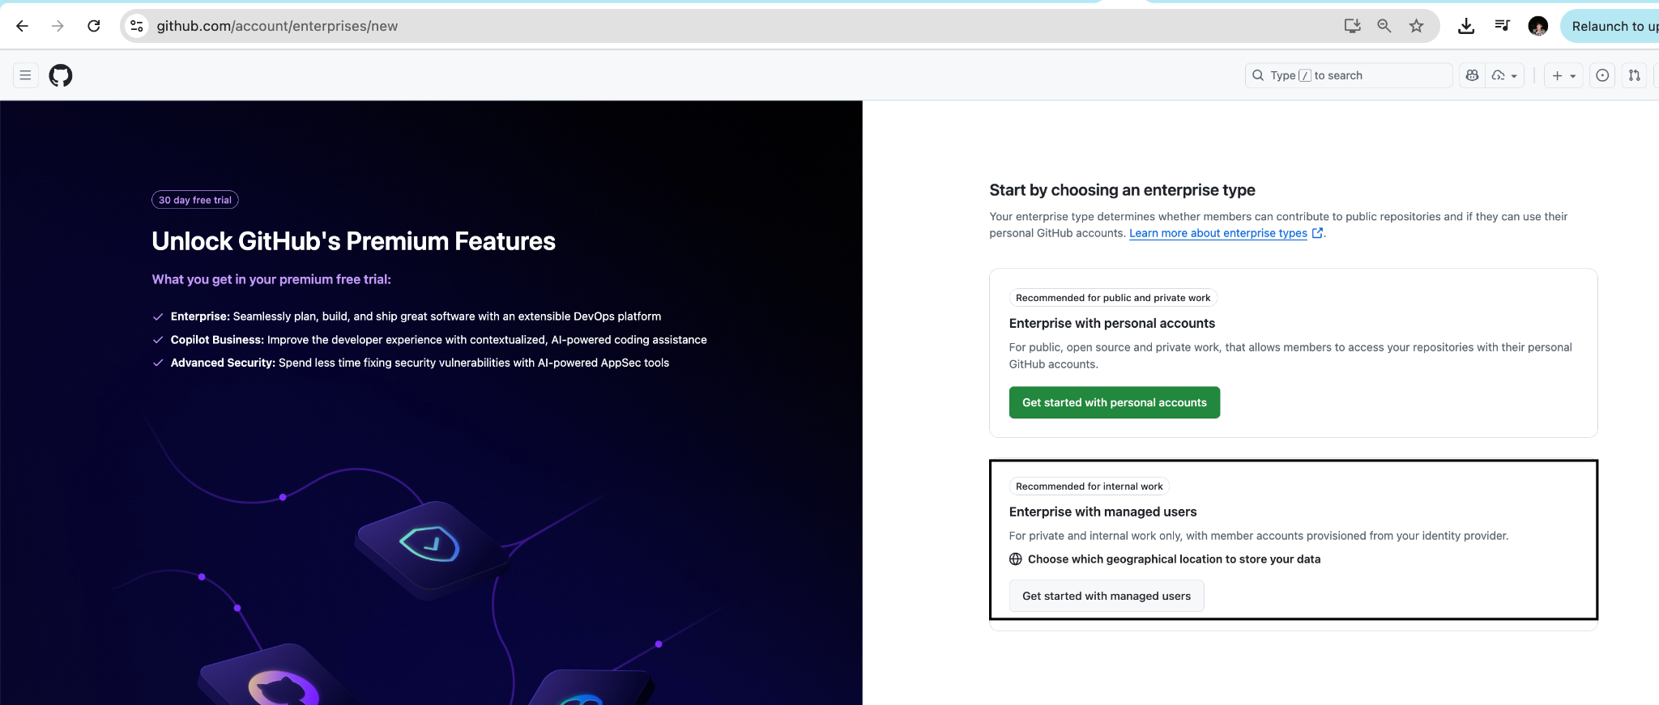

Fill the required information according to your enterprise information

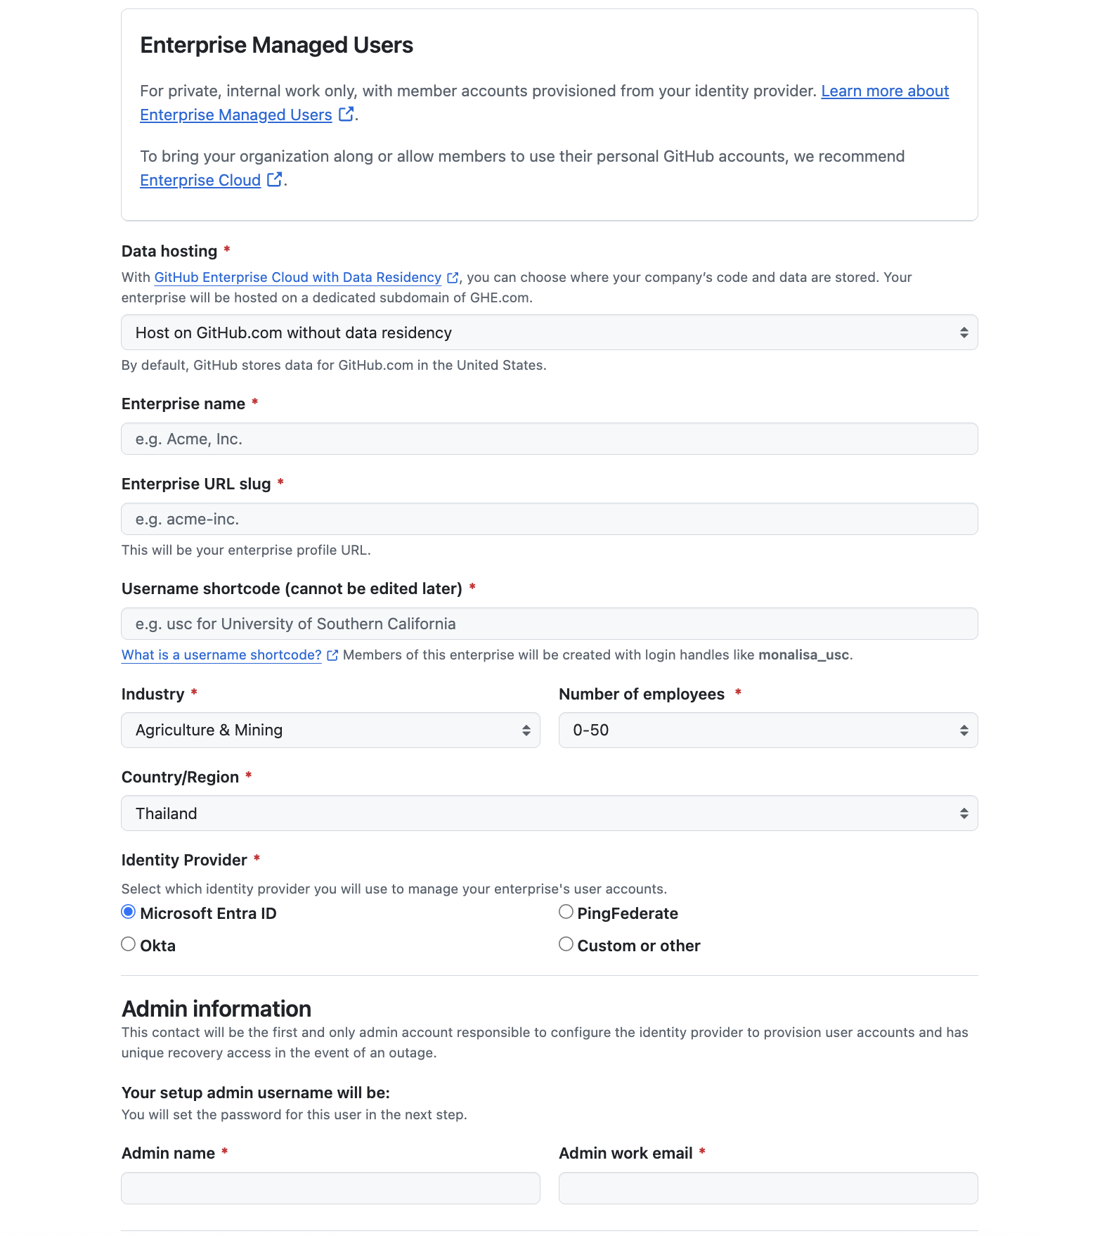

Once you have filled the form you should be directed to this page. (Note, the email you put in will be used to receive the admin account.

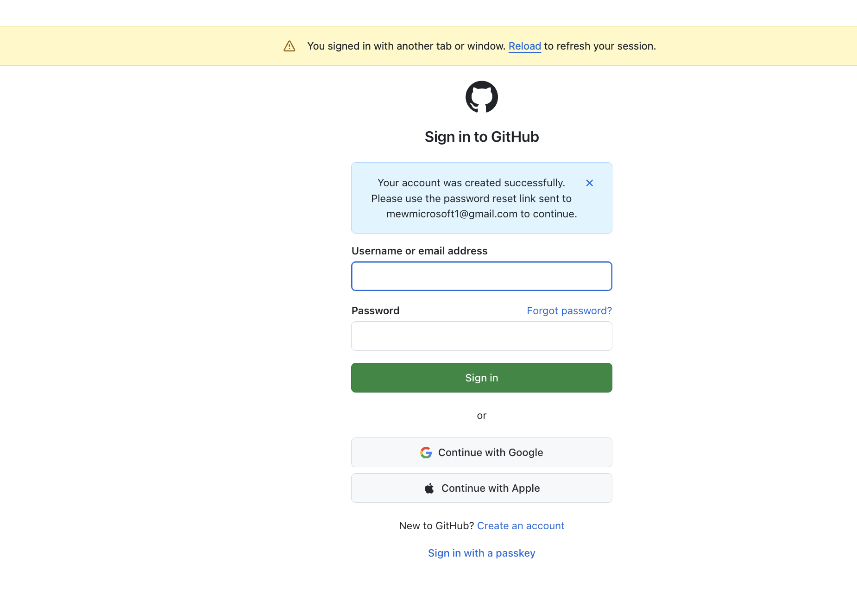

The following email is the email you should receive, please set your password.

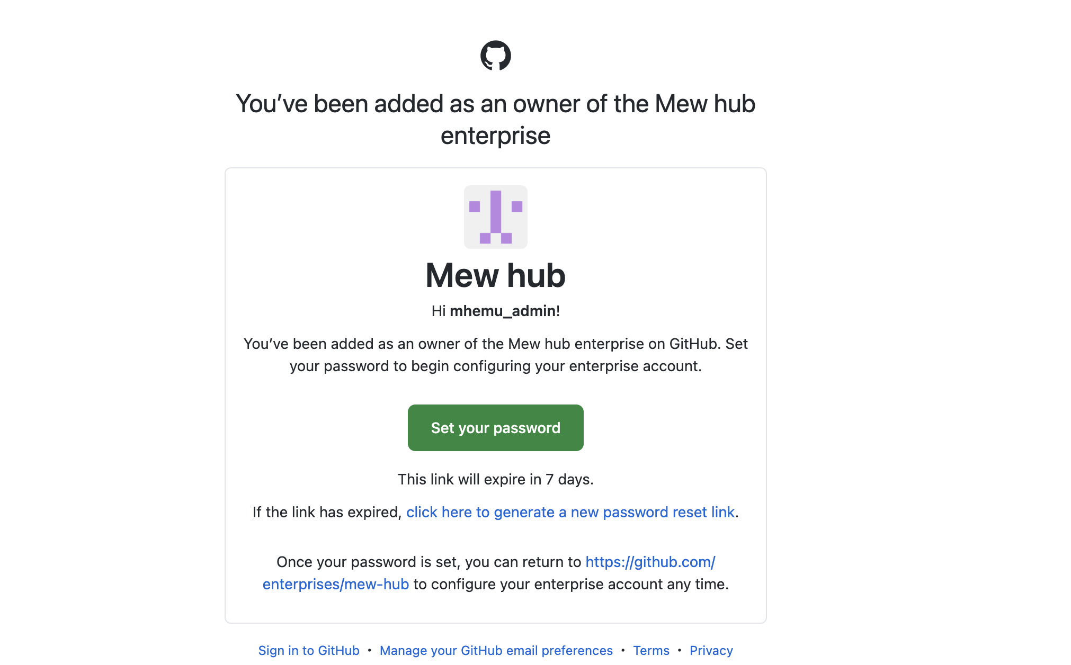

Once, you are in you should see the following dashboard we will complete these 3 activities in order)

1. Generate SCIM Token
2. Enable Single sign-on (We will need azure portal)
3. Configure provisioning.

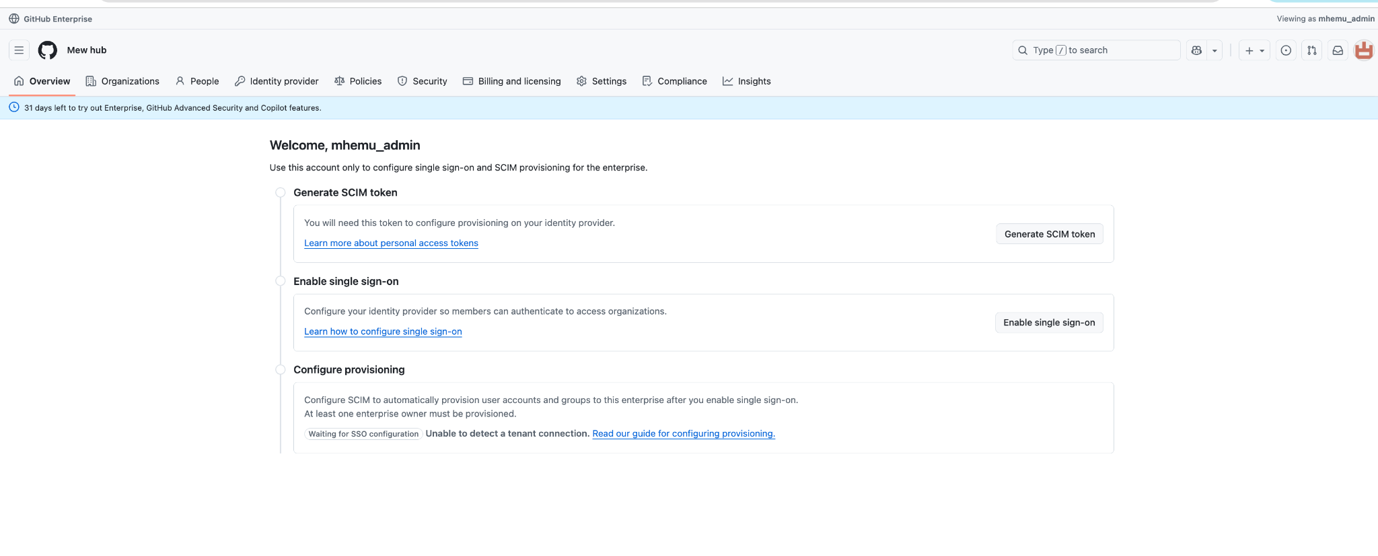

You can click on `Generate SCIM token` or alternatively can navigate to:

(Or Click your Profile Icon on the top right → Settings → Developer Settings → Personal access tokens → Tokens (classic) → Generate new token (classic))

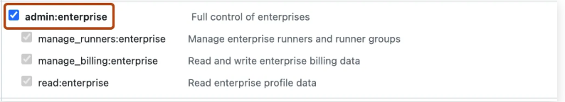

Keep note of this token, we will use it later on.

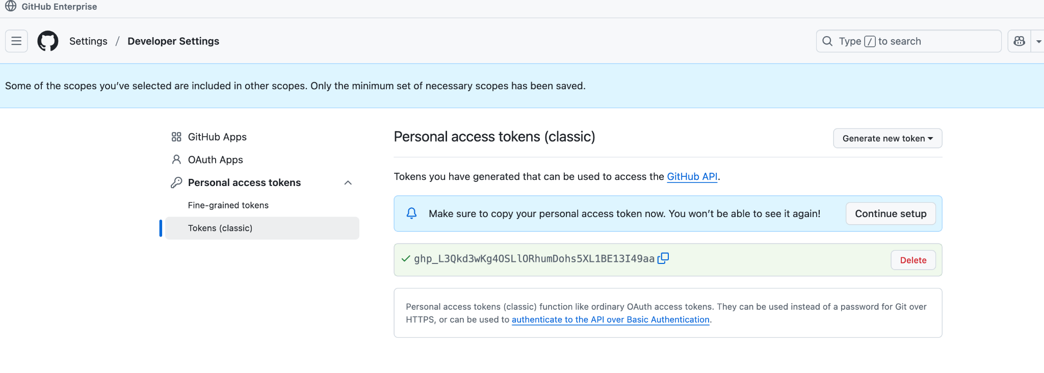

The next part is to enable single sign on. As mentioned here we will use azure entra id.

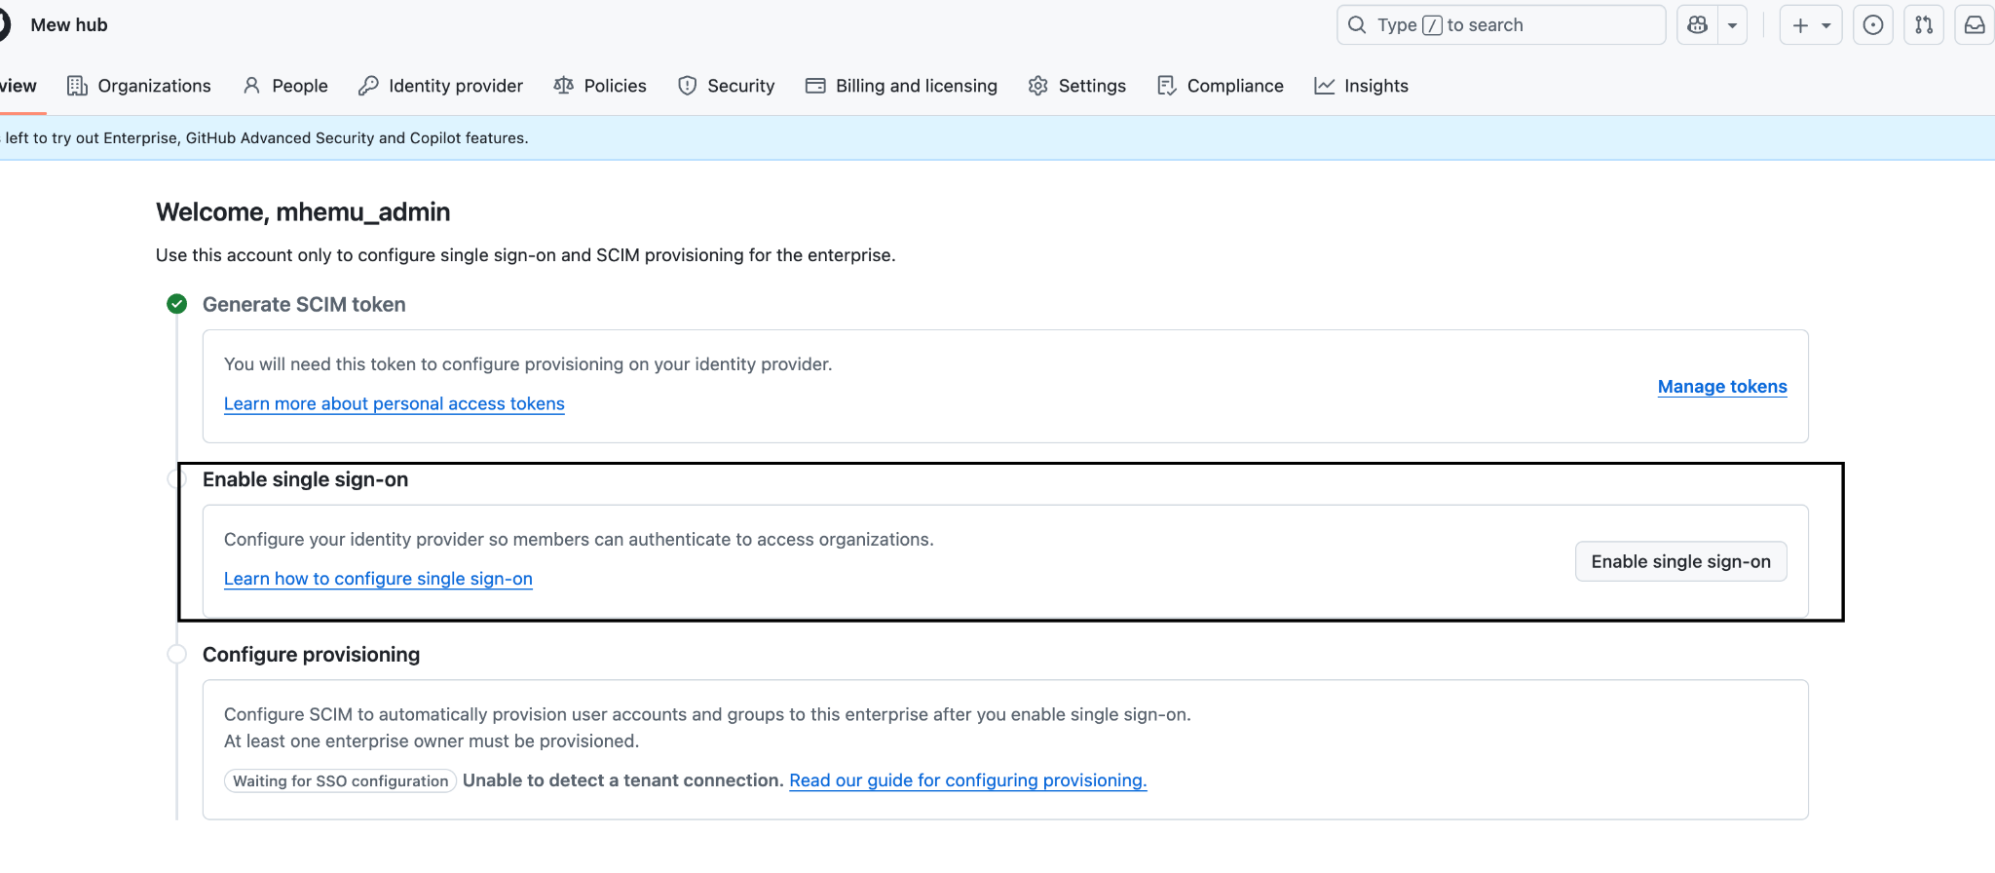

Github enterprise supports both OIDC & SAML, but in this tutorial we will focus on OIDC.

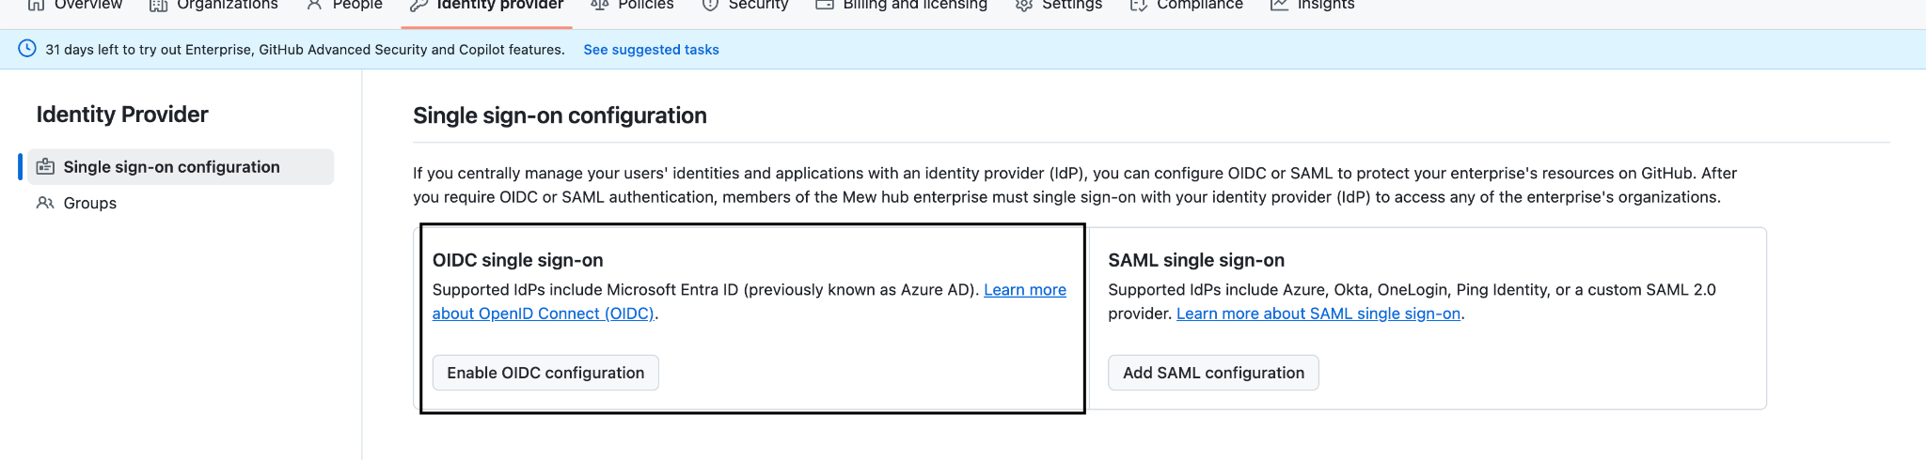

Once, you enable you should be prompted to log into your azure account, as follows:

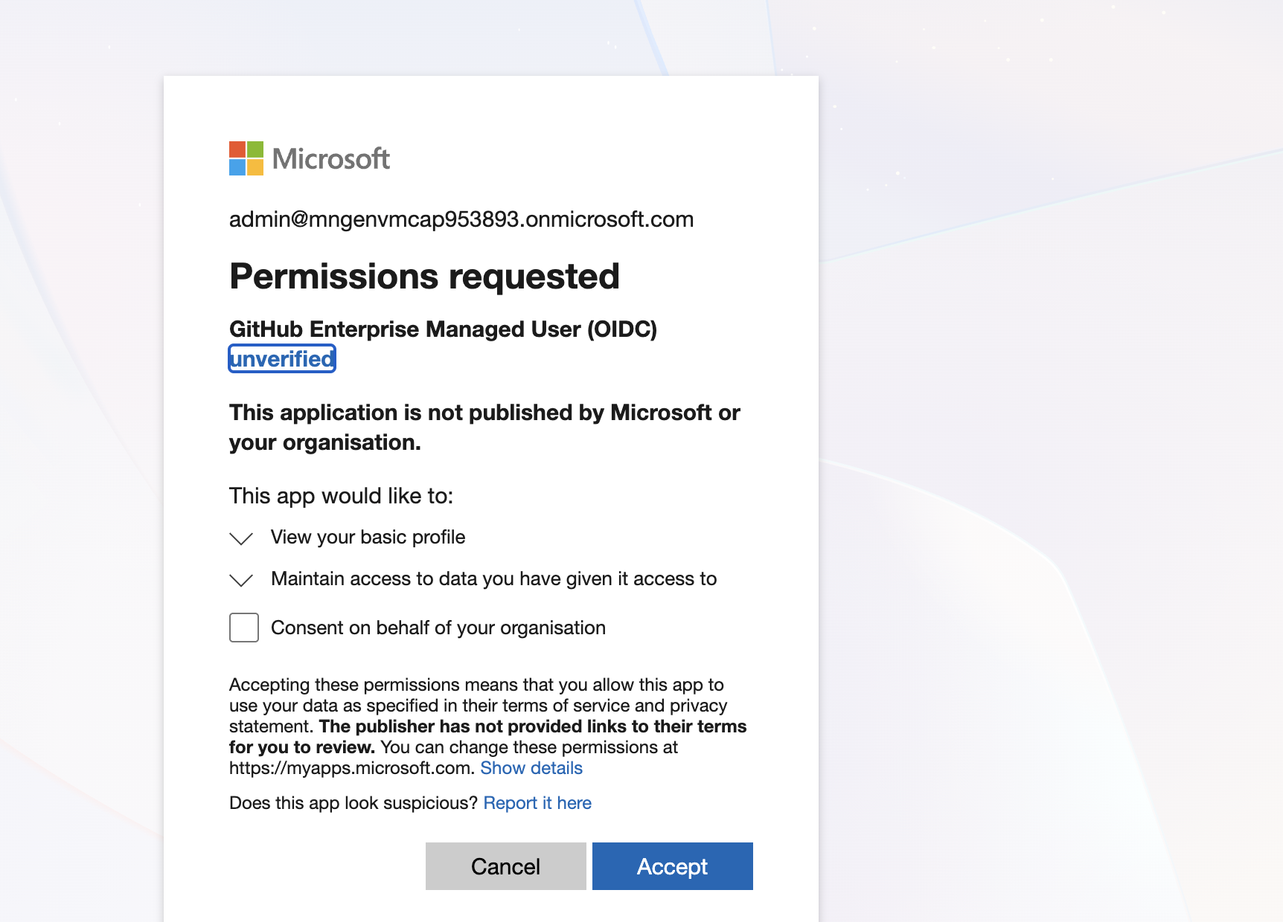

If you navigate to “Enterprise application” (Can search in the bar), then you should see Github Enterprise Managed User (OIDC) as one of the option.

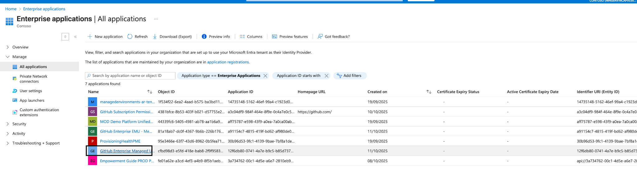

Please click on GitHub Enterprise Managed User (OIDC)

First things first, we are going to assign our first user (from entra id, if you don’t have a user be sure to create one). Please click on Assign users and groups.

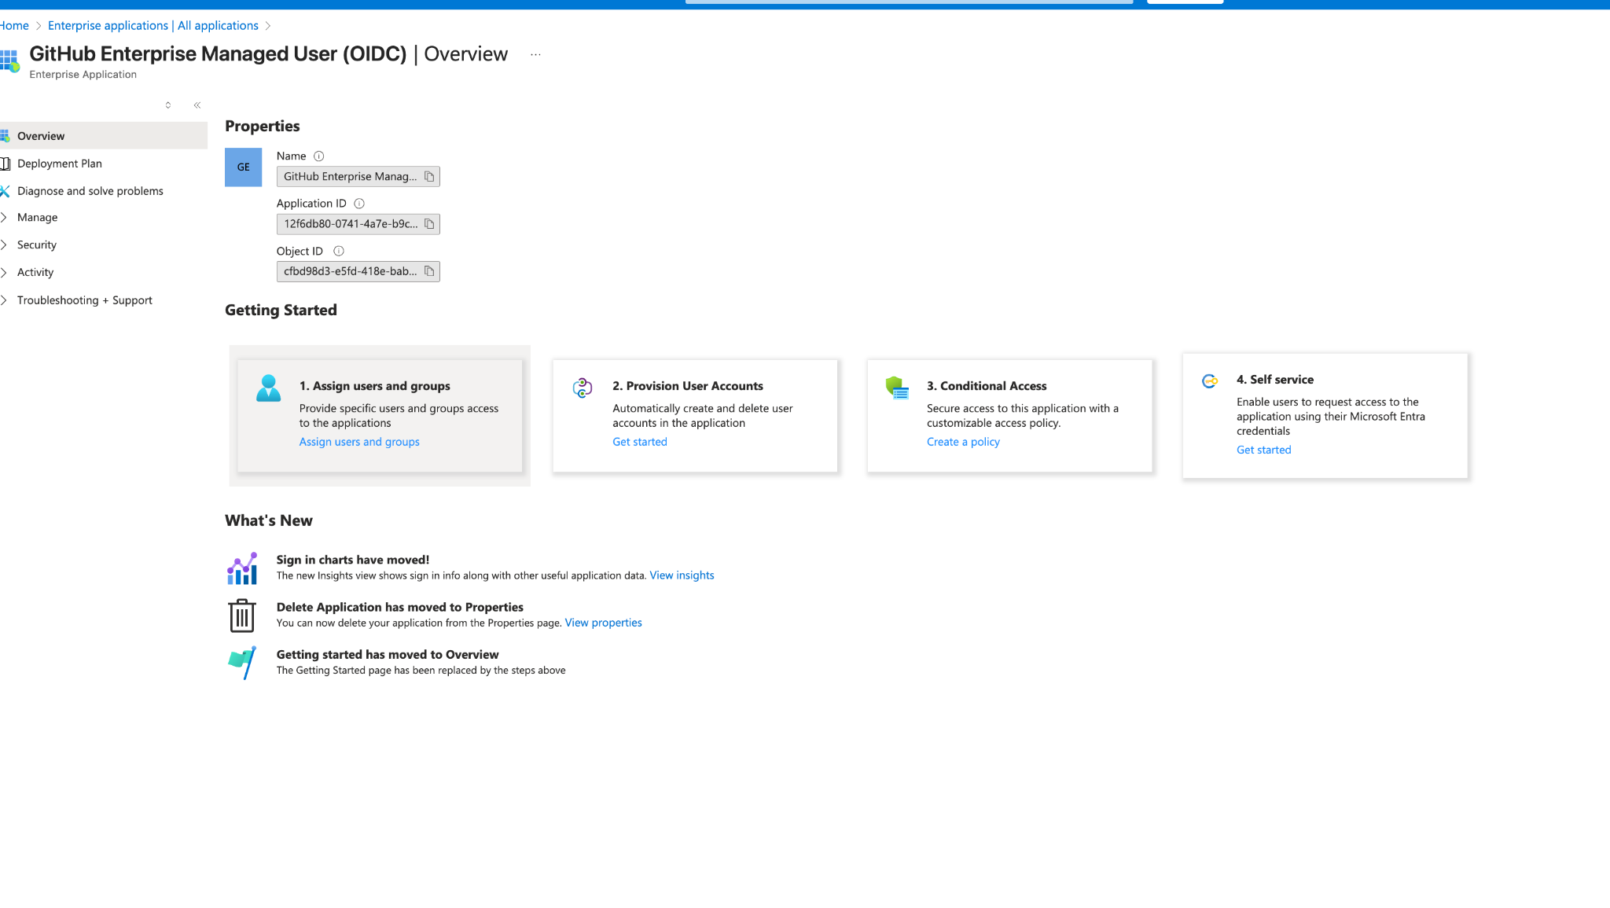

We can assign both users and groups. (Groups contain multiple users). We will start by assigning a user as enterprise owner. See Below:

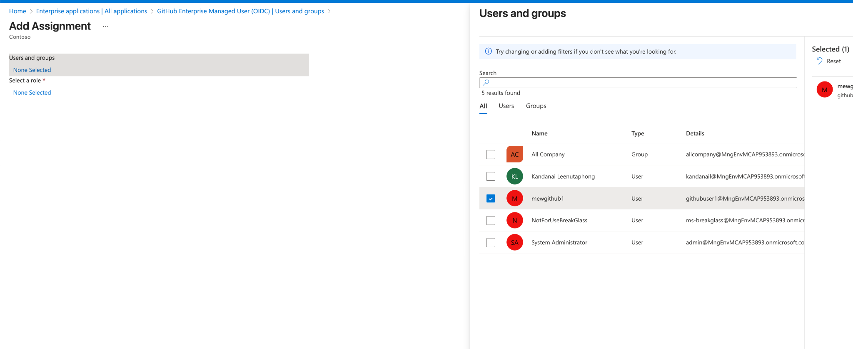

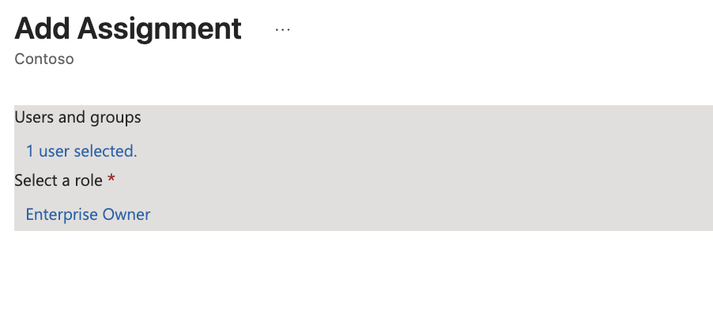

Once the user has been assigned, we will head to provisioning.

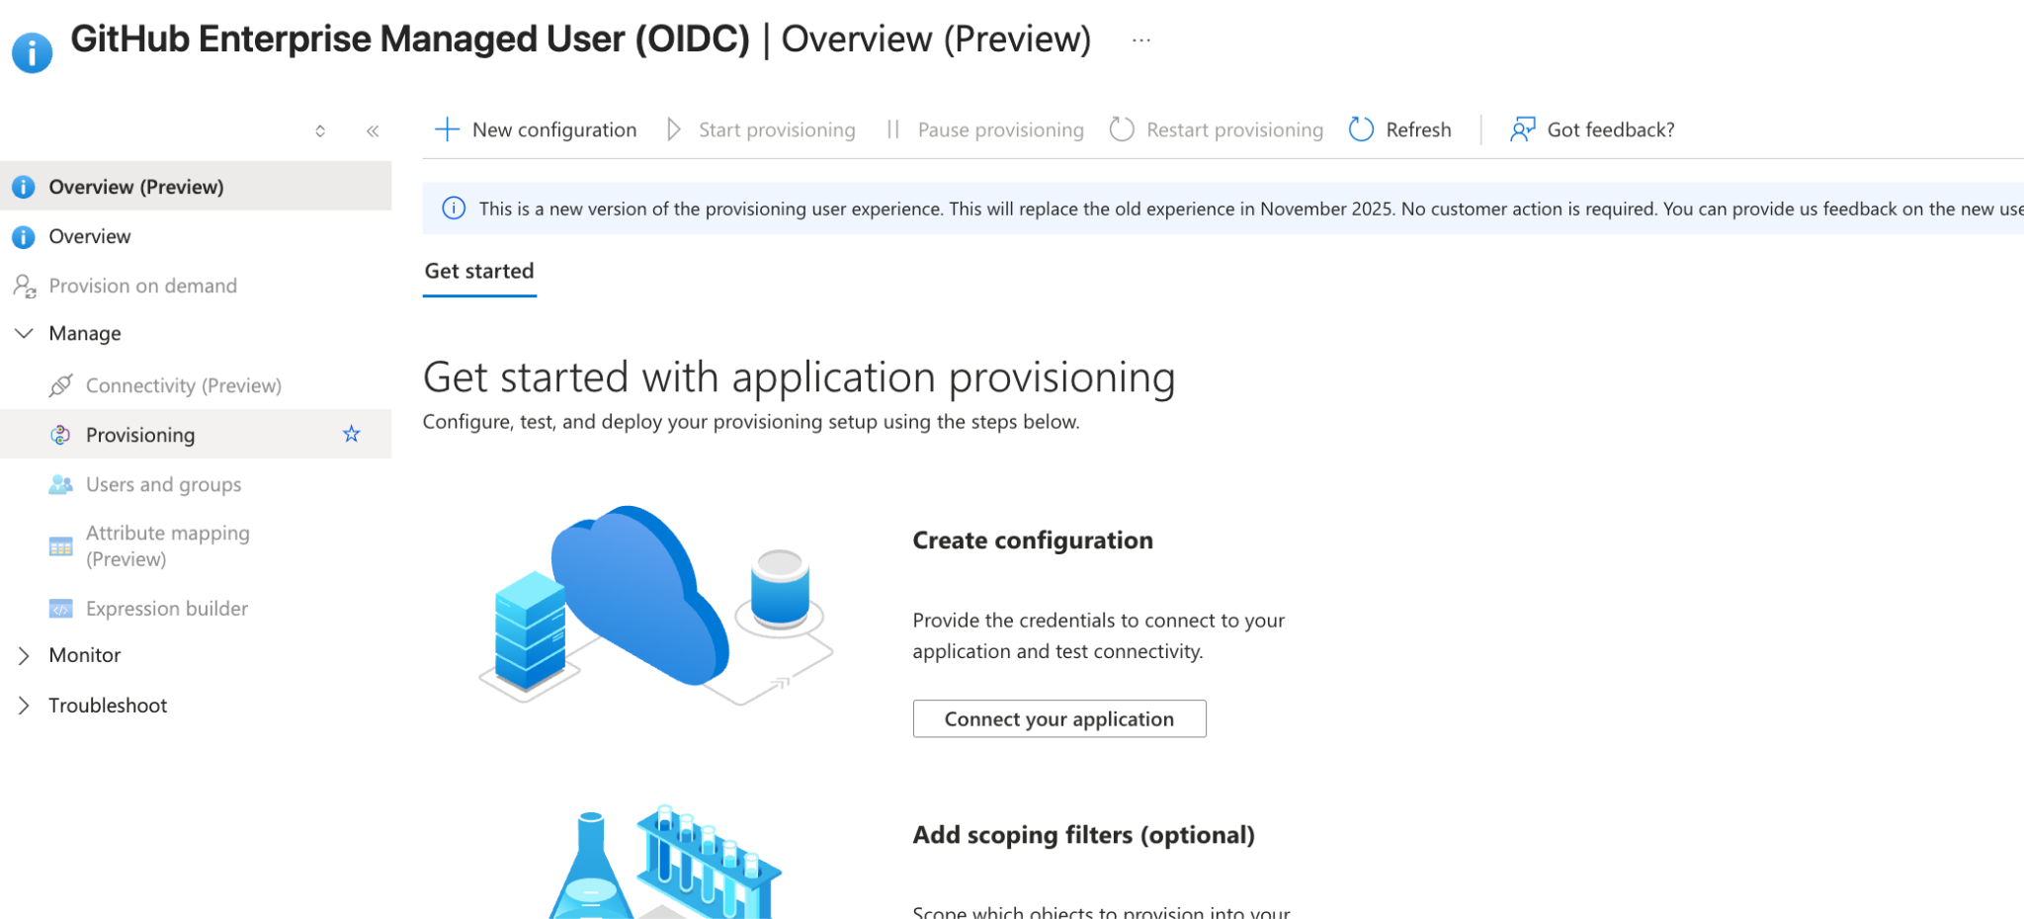

Next go to provisioning and fill the following form:

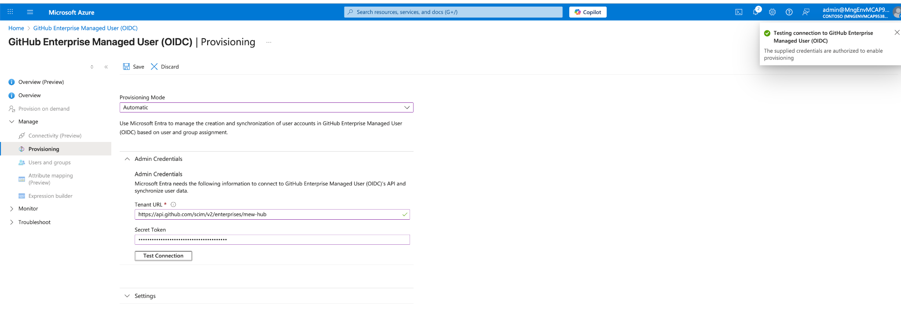

1. Set Provisioning Mode = Automatic (This means users will be added automatically every 40 minutes)
2. In Admin Credentials, enter the following, replace {enterprise_slug} with your actual enterprise name you created. You can identify this from the url to your enterprise github.
   * Tenant URL: https://api.github.com/scim/v2/enterprises/{enterprise_slug}
   * Secret Token: {PAT from Step 1}
   * Test Connection
   * Click Save

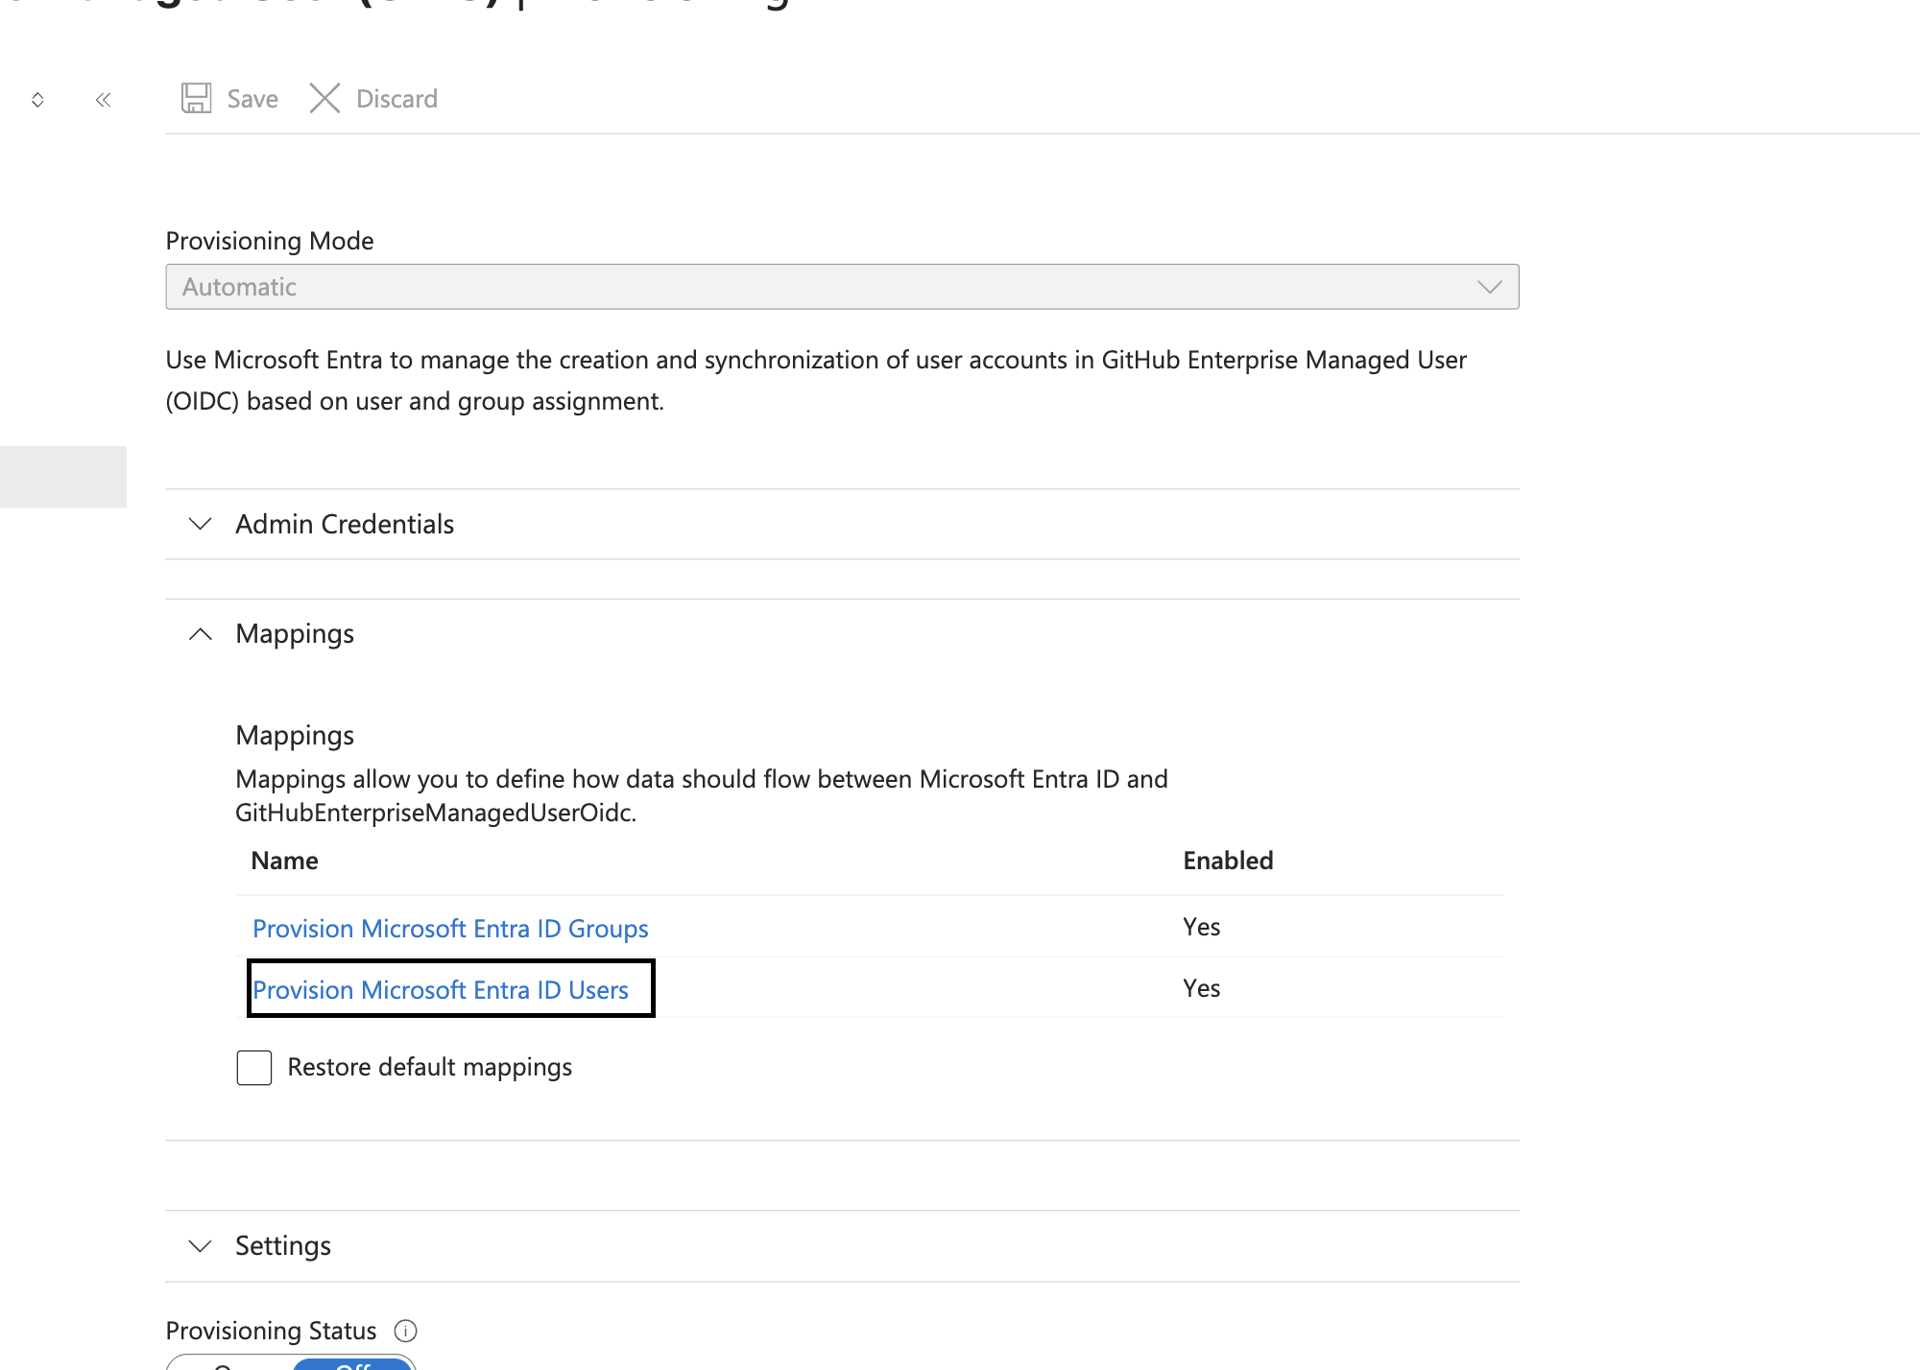

* Add missing mappings as needed inside provision Microsoft Entra ID users (In my case, it was missing home and other)

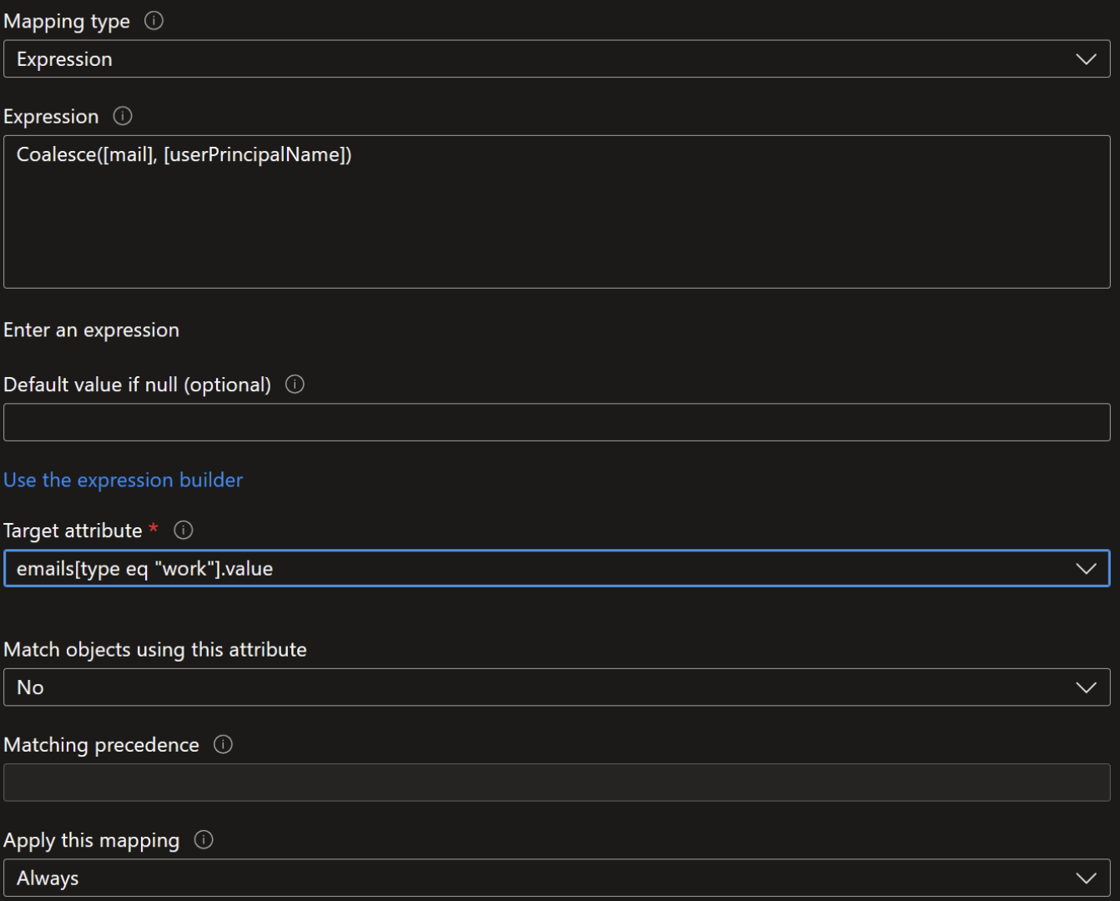

Reference: <https://raffertyuy.com/raztype/ghec-emu-initial-setup-entra-oidc/>

* Expression: Coalesce([mail], [userPrincipalName])
* Target attribute: {as above} - Click Save

This is what it should look like at the end.

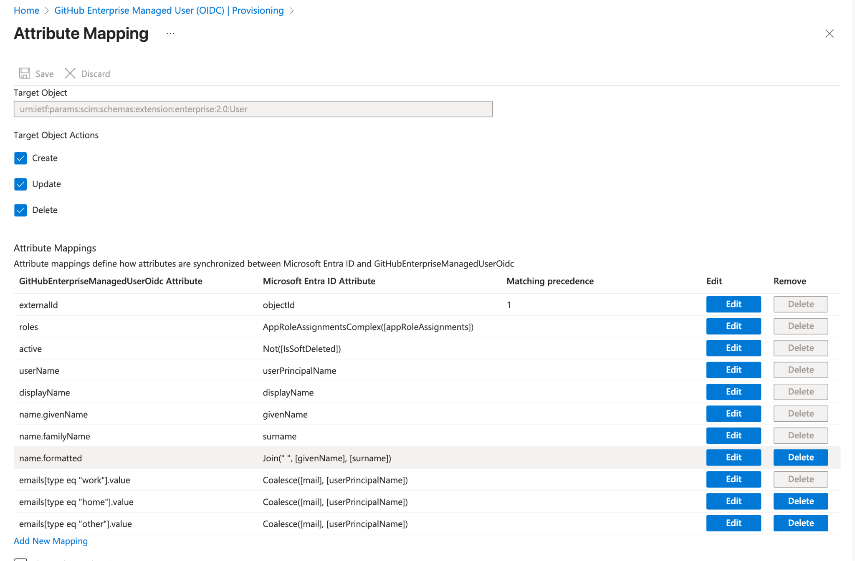

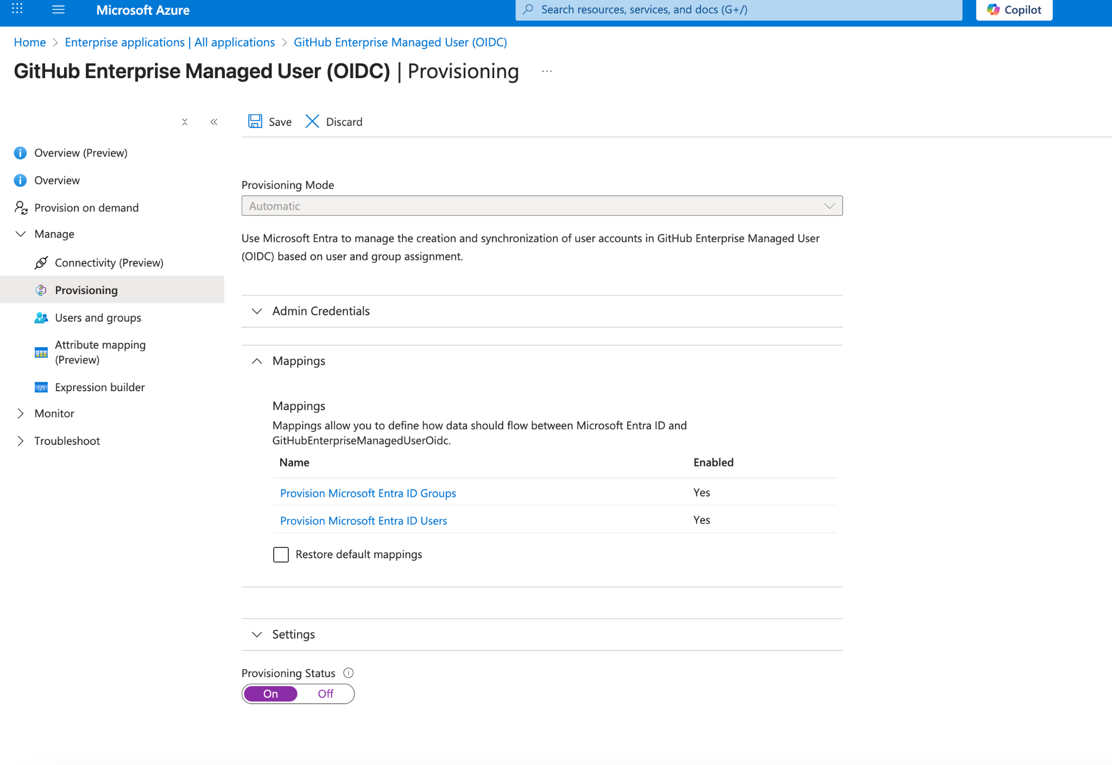

Set the provisioning status to be on.

Wait for up to 40 minutes. Then status will turn from

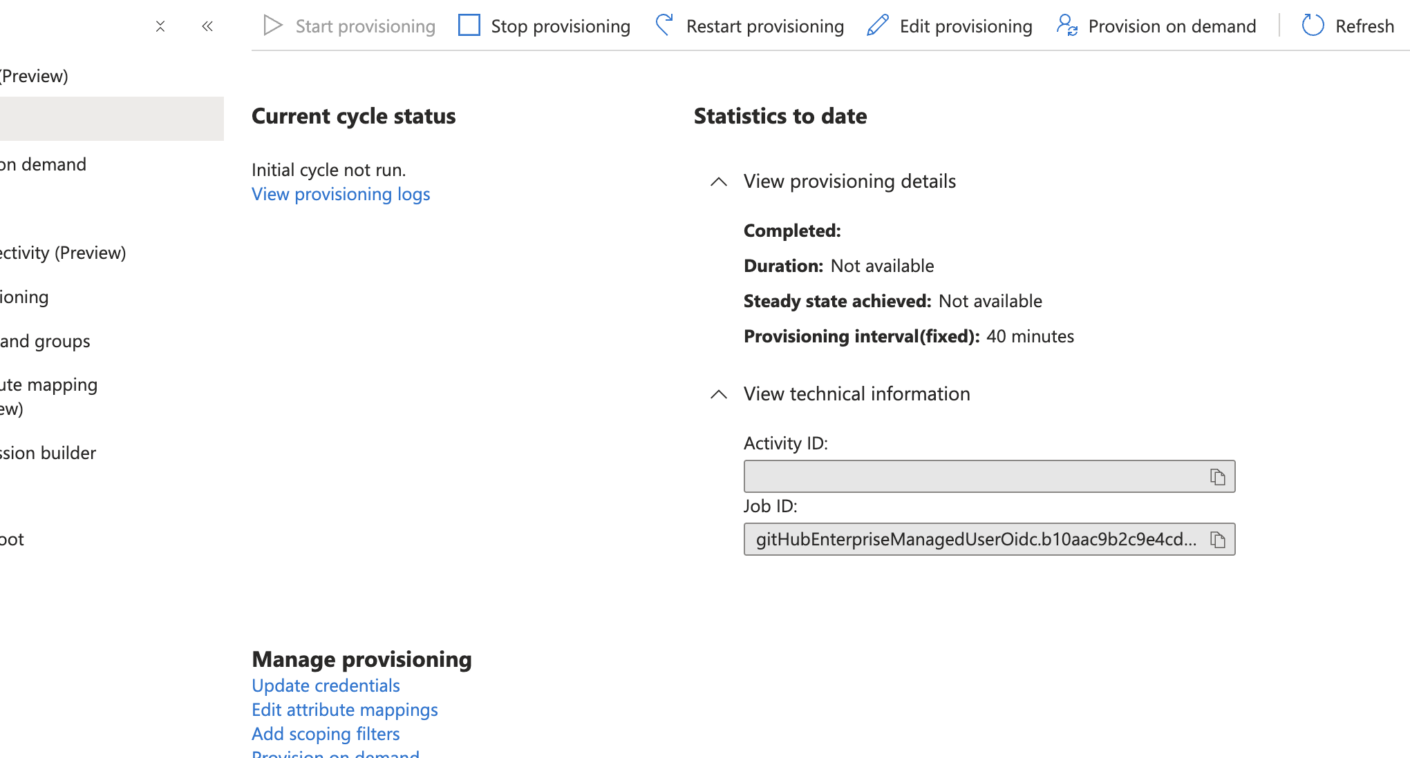

TO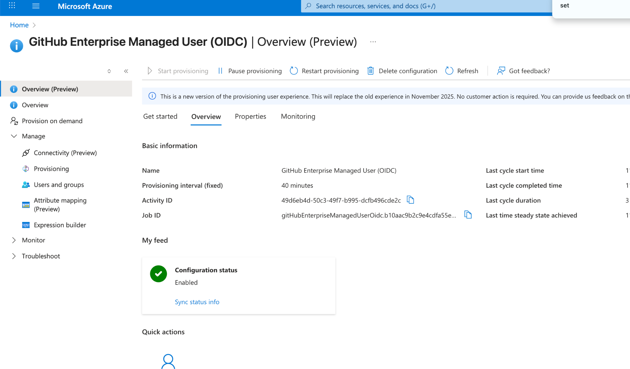

Successfully configured.

If you navigate back to your enterprise github, you should see you are ready to go.

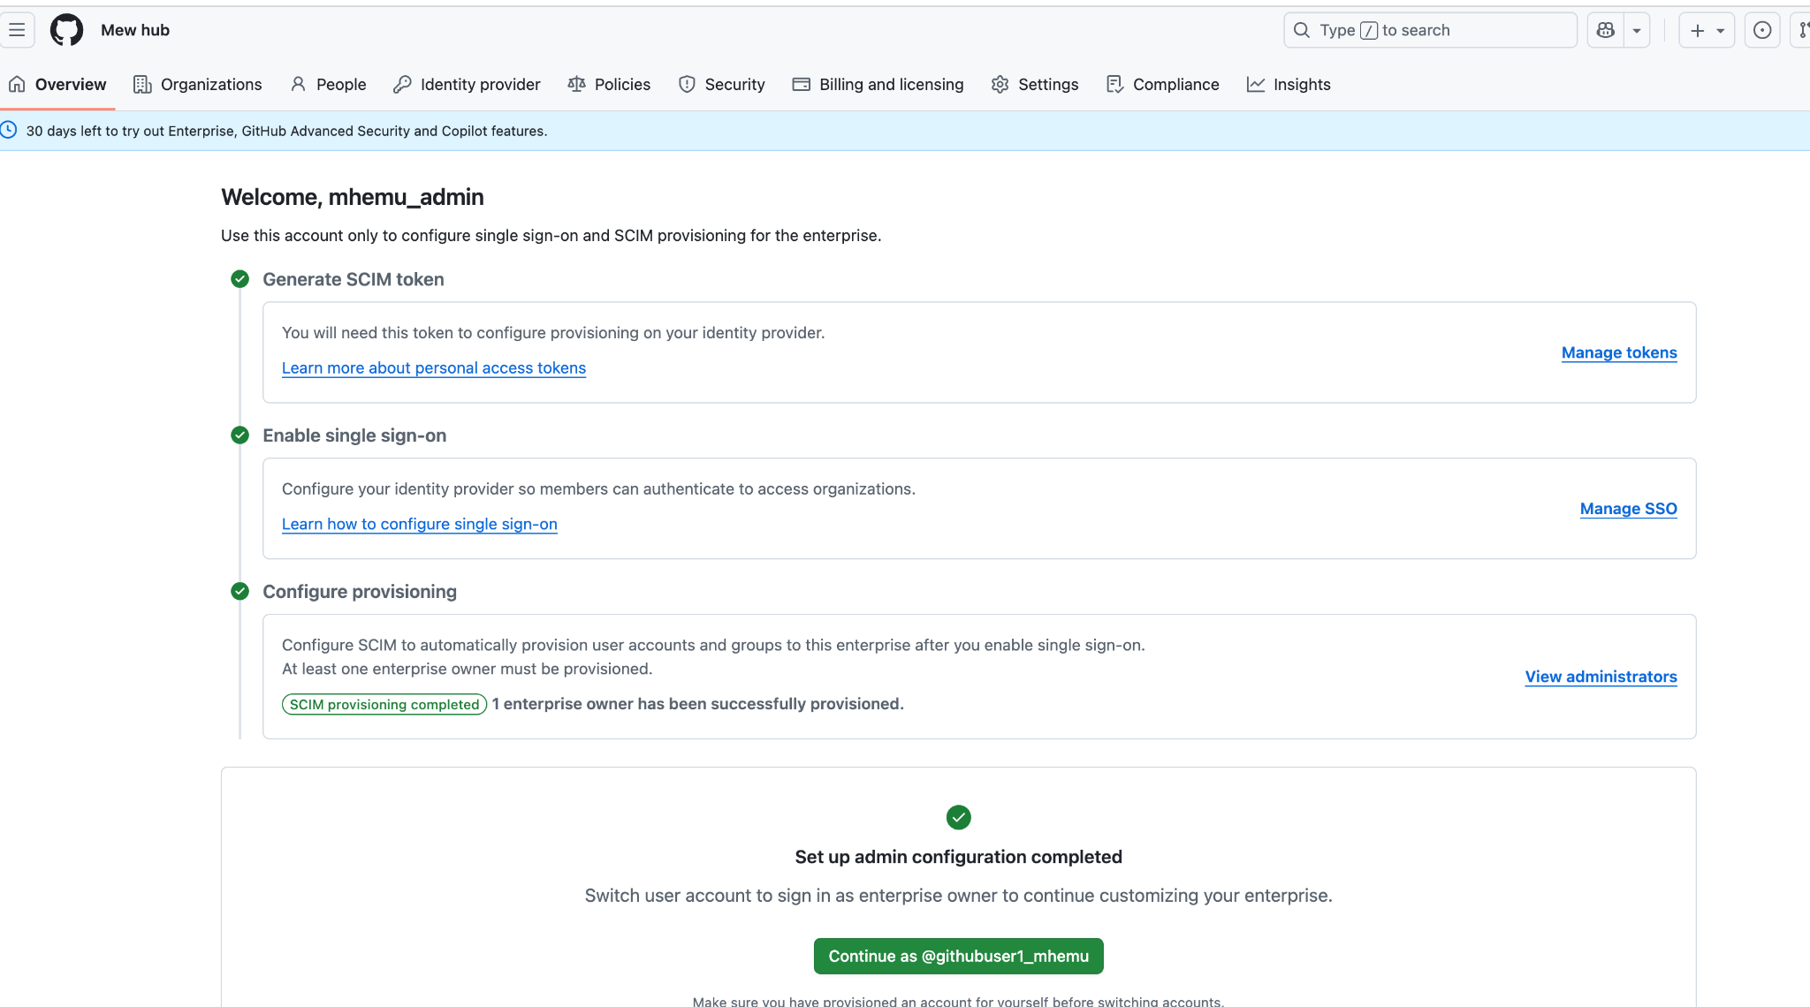

The non-admin account can now be accessed (NOTE: You may need to install an authentication app). Feel free to create organization within the enterprise. (You can have many organizations in an enterprise)

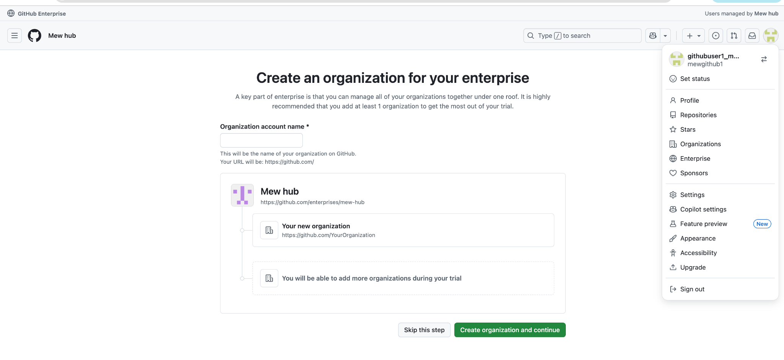

Now that you are ready, go ahead and “Activate the paid Enterprise”

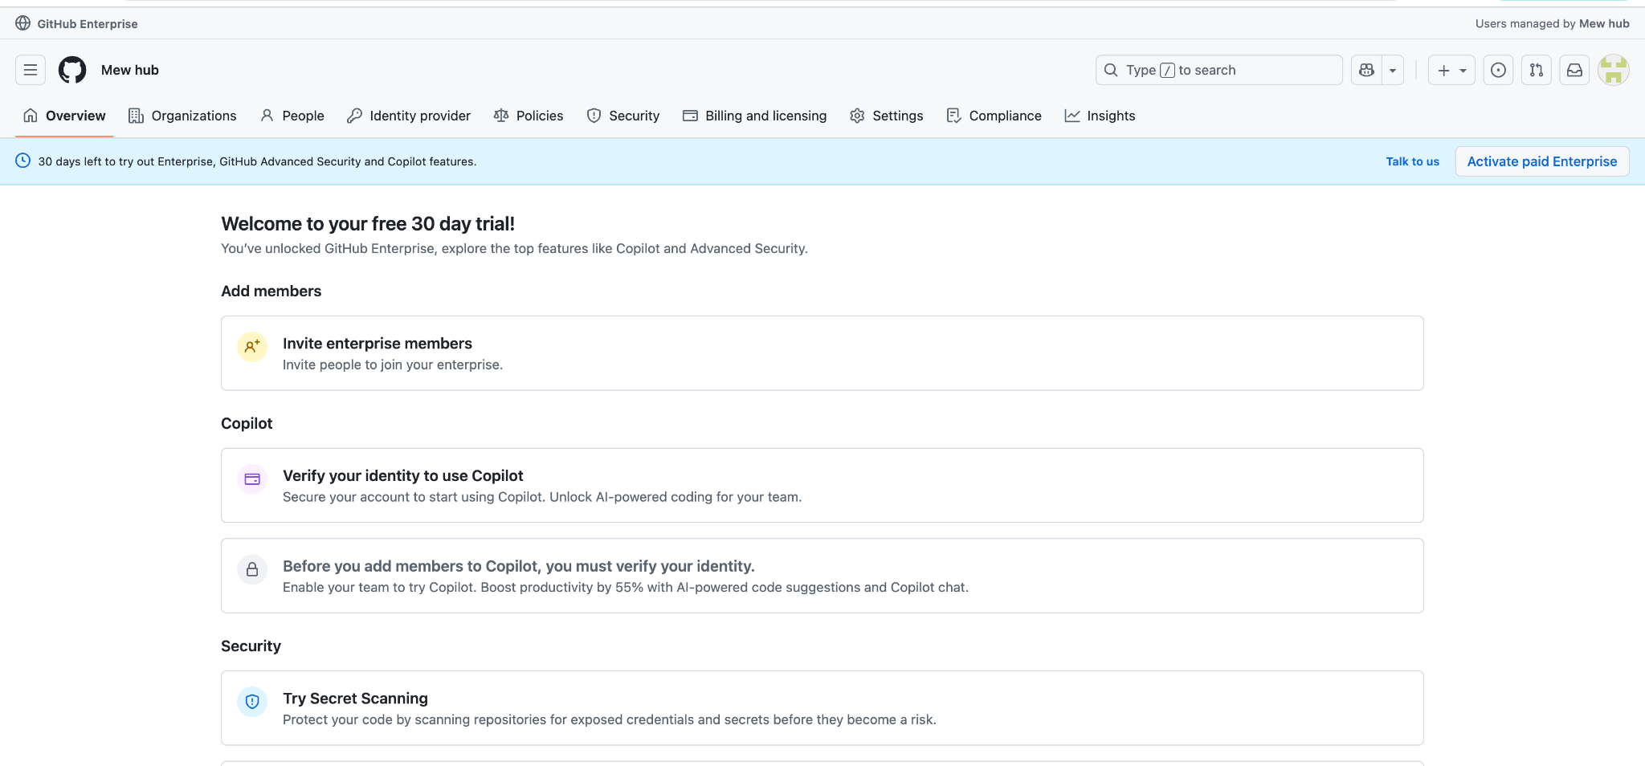

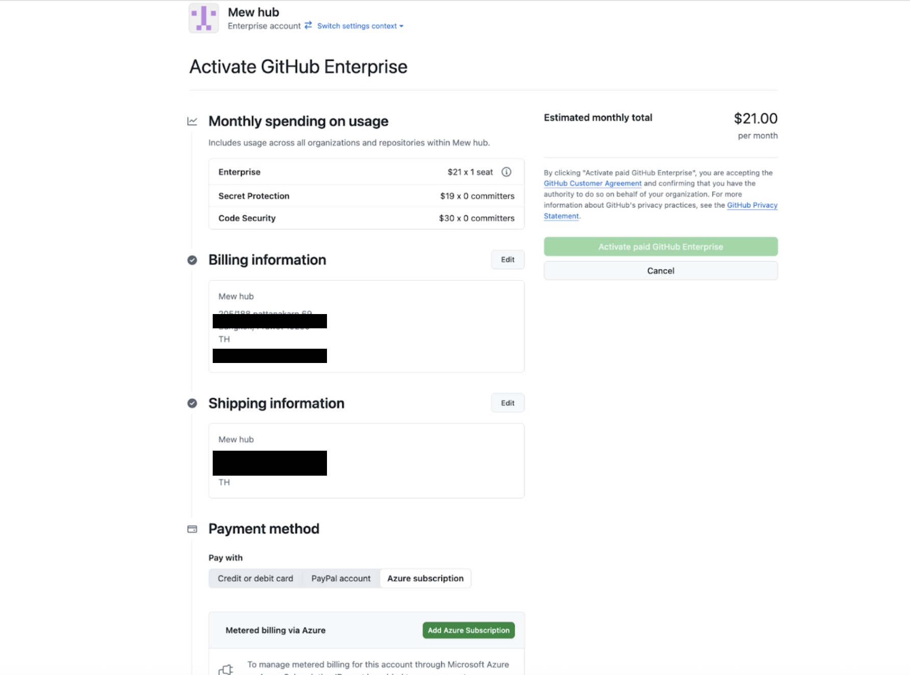

Please fill in your company addresses for payment.

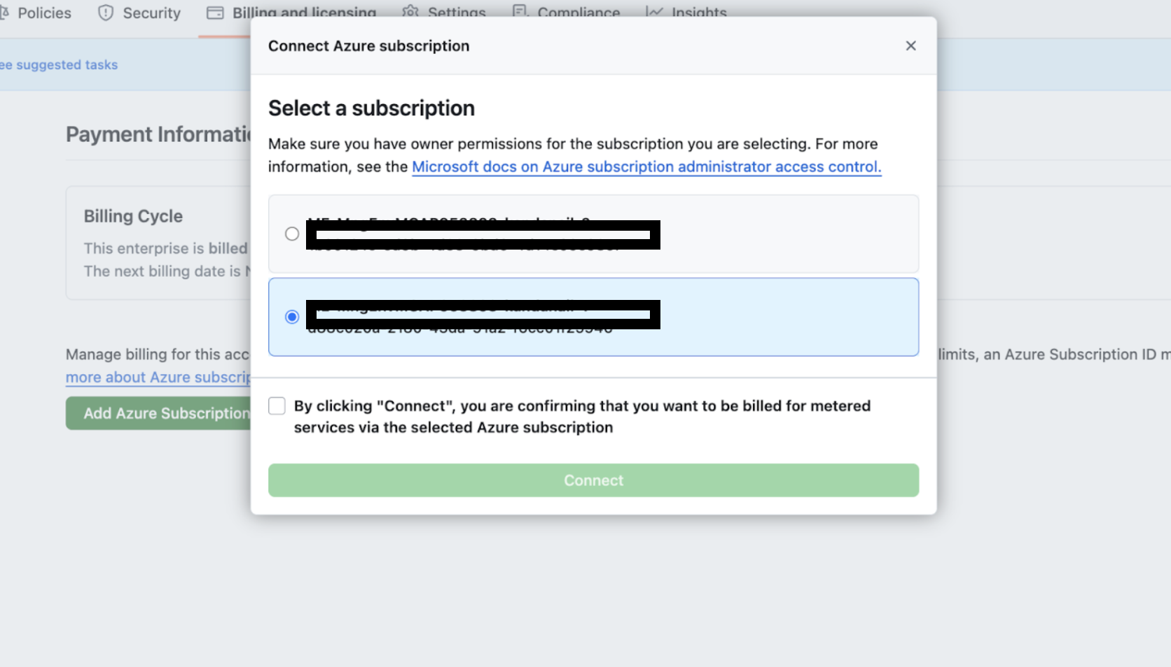

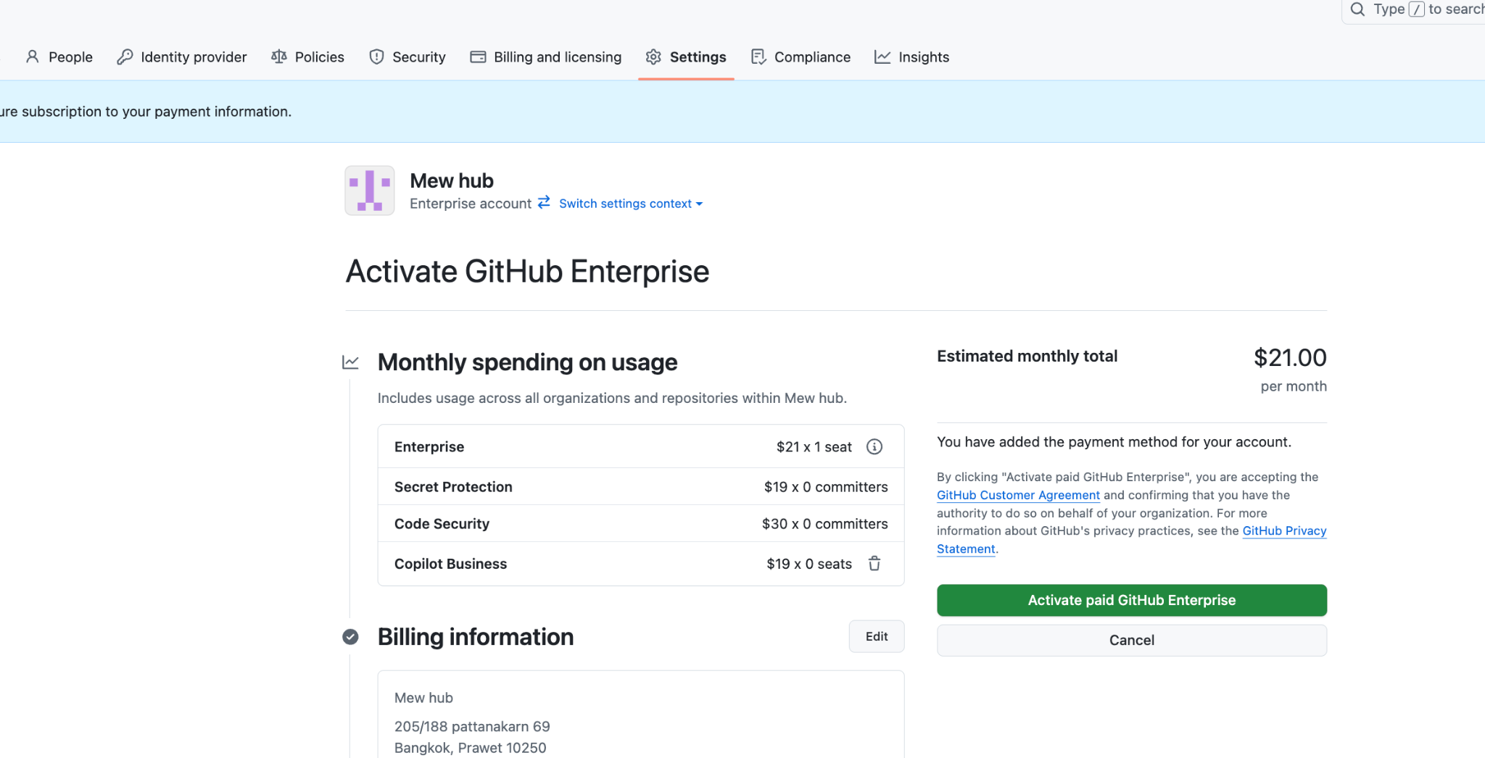

Then, click on activate paid Github Enterprise.

You are ready to go!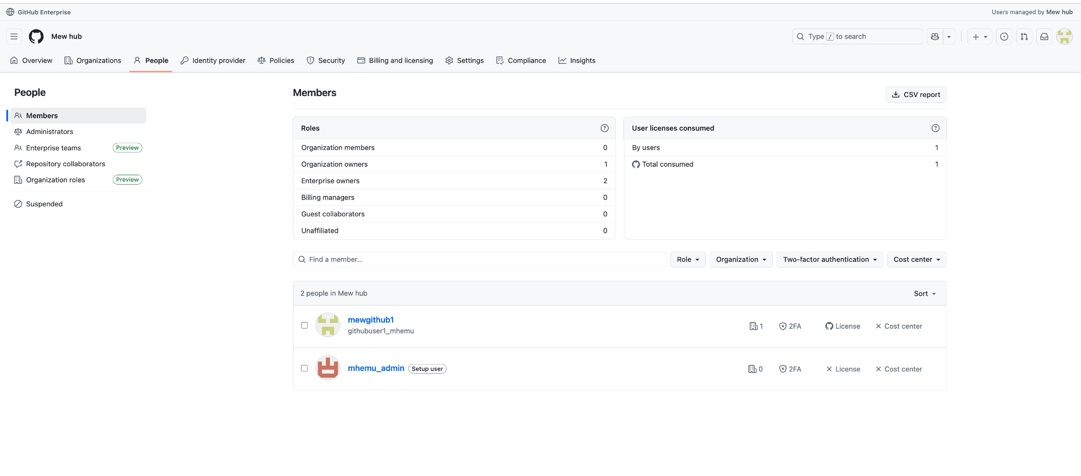

For, Future sign ins: (Ensure you are logged out of your current github account first) then sign in with:

[https://github.com/enterprises/](https://github.com/enterprises/mew-hub/){slug_name}

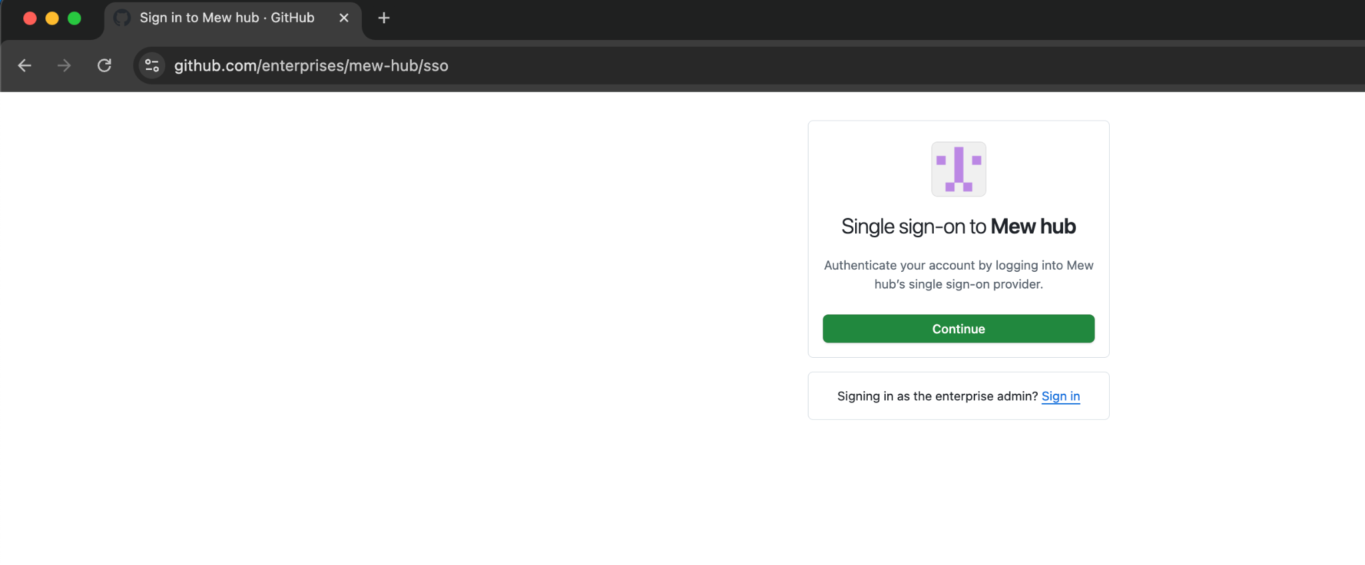

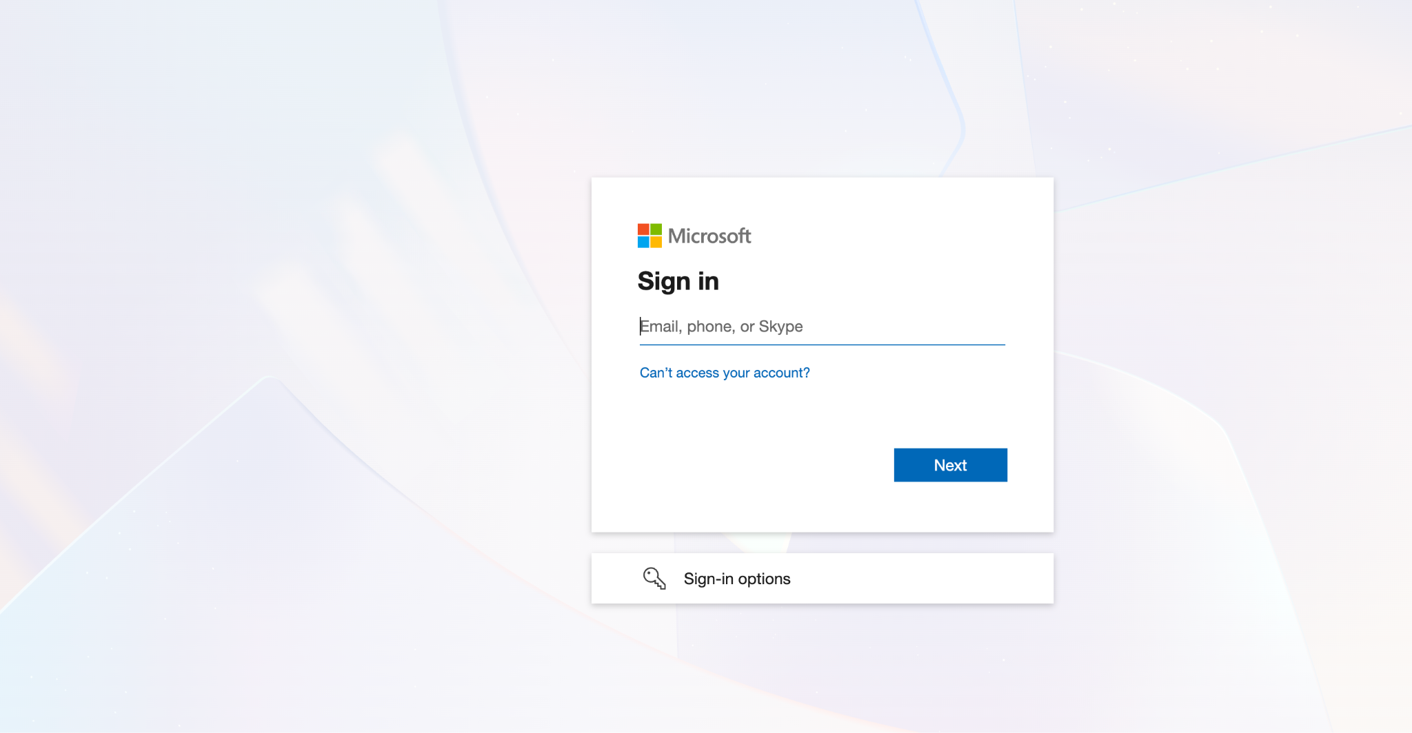

If you are using Microsoft entra ID, you should be redirected to sign in with a Microsoft account all the time, including other people in your organization.  
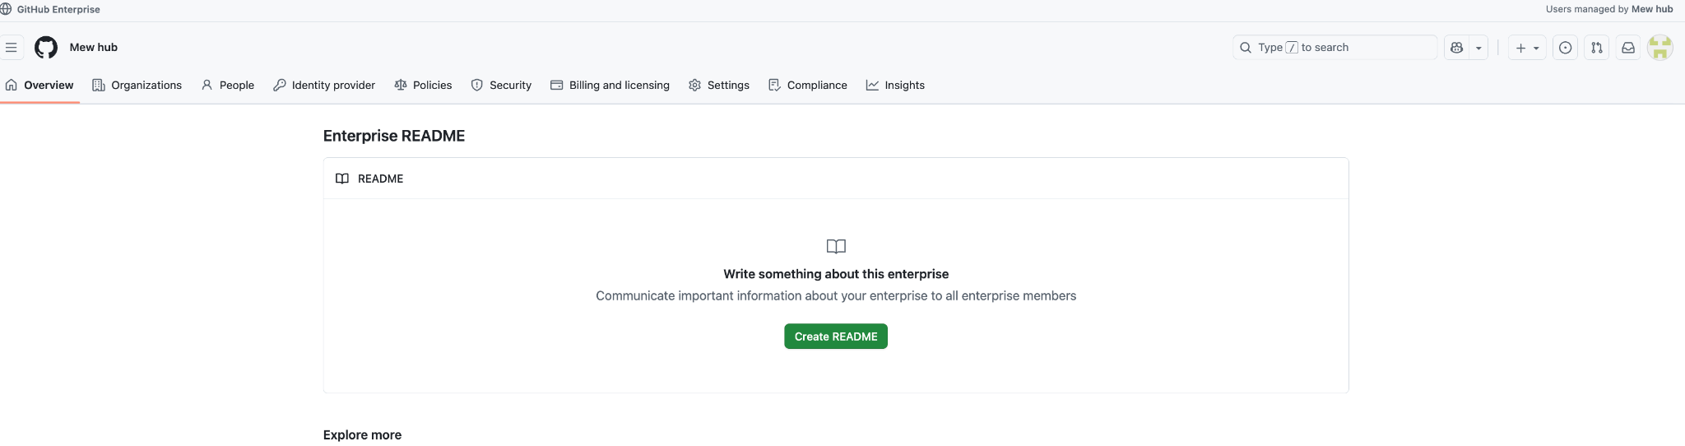

**END**

**APPENDIX**

**How to add new users/groups in and monitor your cost??**

We will start with how to add a user in.

Here we will add another user (githubuser2)

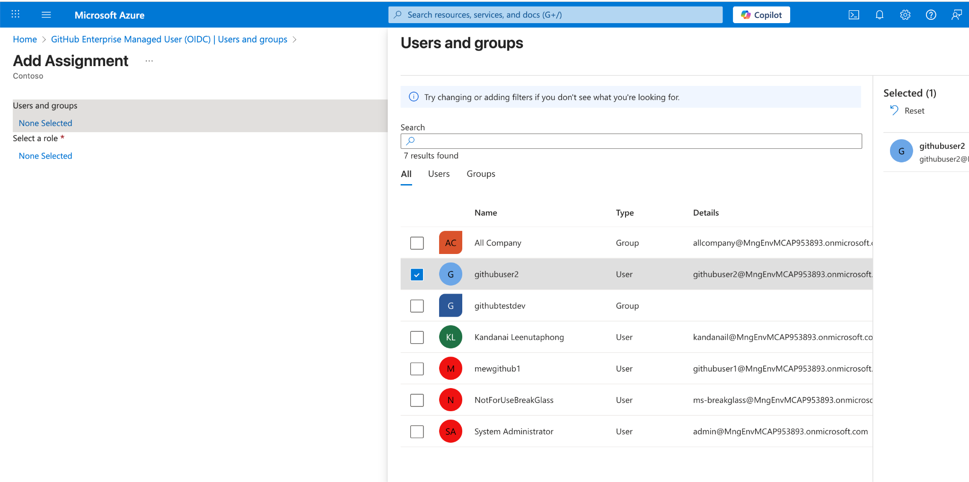

Here you will see that there is only 1 user, this is to be expected if you wait 40minutes, after adding a user you should see the number increase. If you are in hurry, you could also provision manually.

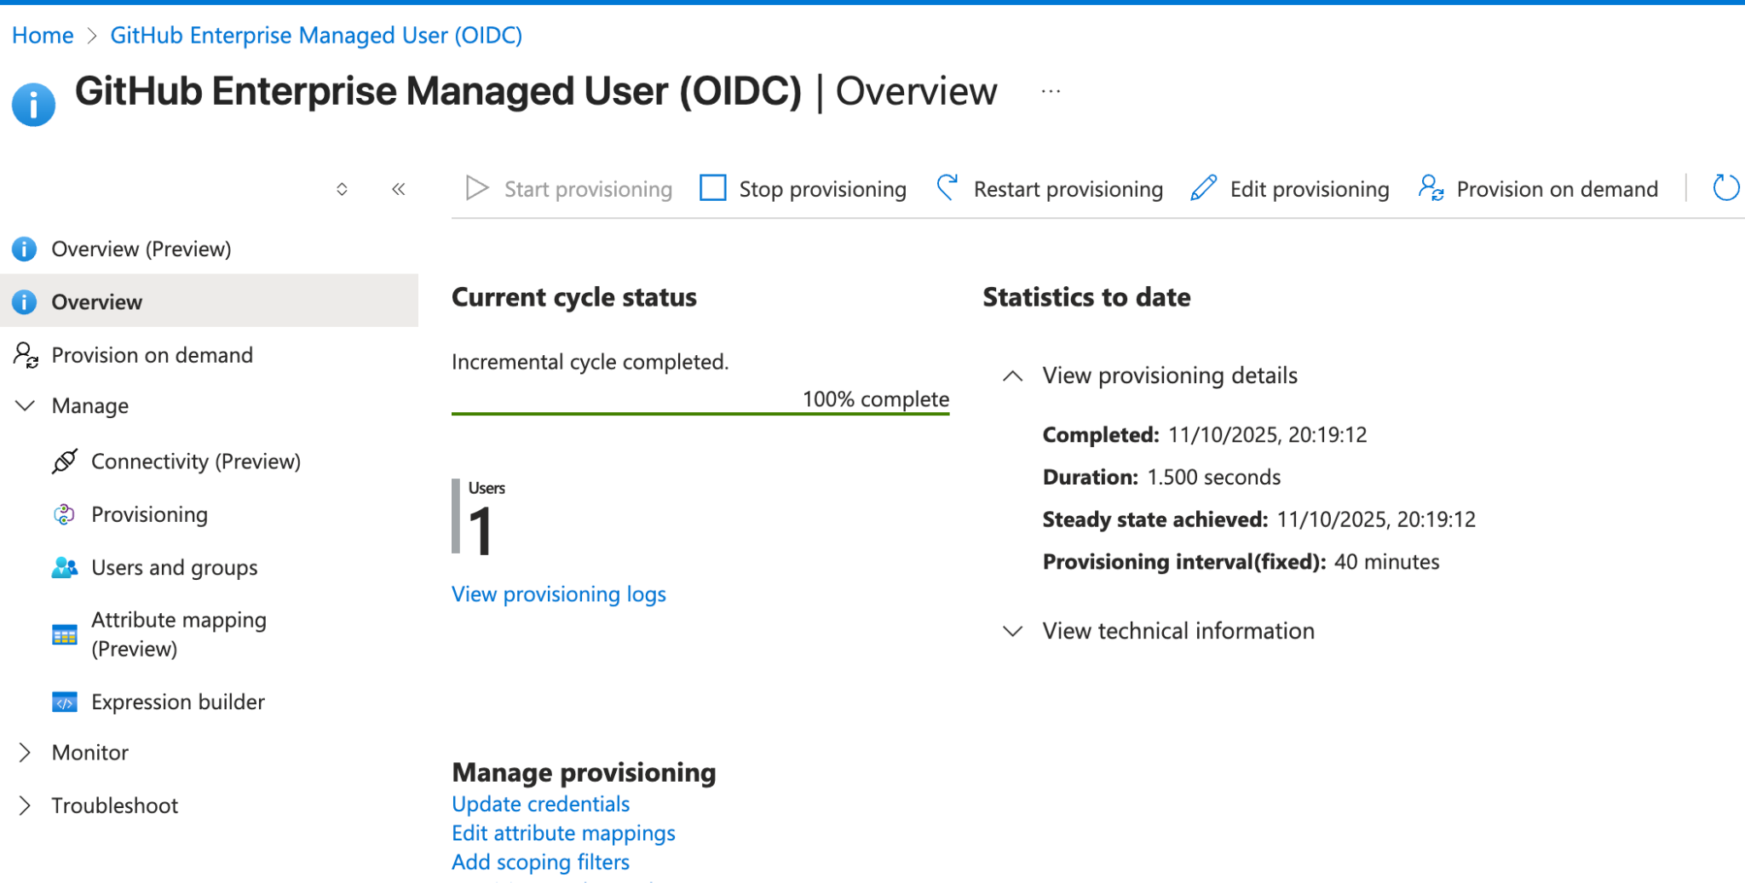

After a while you should see a new user added to your enterprise.

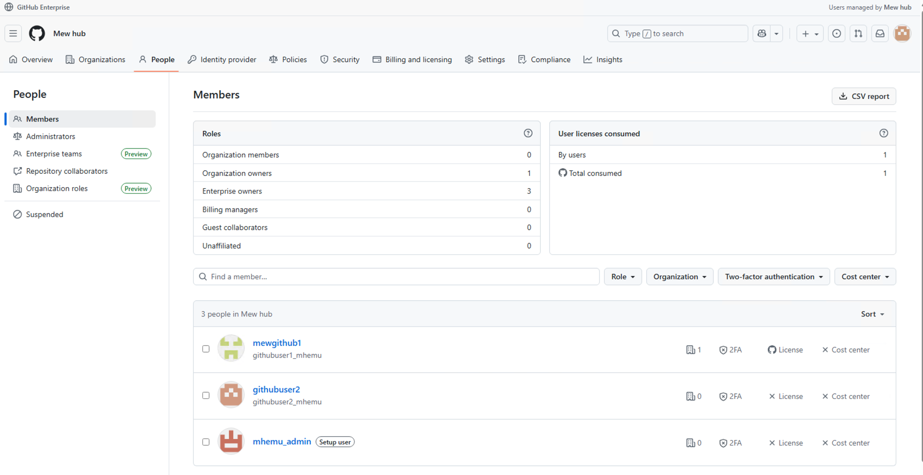

You can add the user added to your enterprise to one of the organizations. You will be consumed by the maximum number of unique users active in an “organization” (Not enterprise)

Examples:

1 enterprise

3 Organization (you have user1 in organization1, user1,user2 in organization2, user1,user2,user3 in organization3) Then you will be charged 3 consumed licenses which is the maximum “Unique people” in your organization.

For the time being I only created one organization with 2 users in an enterprise that is why it charges two licenses.

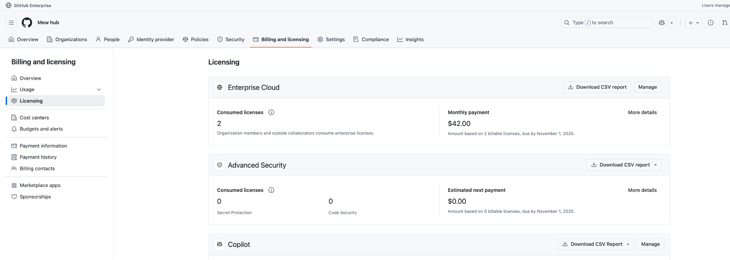

Adding in one person at a time can be time consuming if you already have a group with multiple users already. Here I will show how we can also add github groups. Todo so:

* Please create a github group and assign relevant users in. I have already done so.
* Head back to Enterprise application -> Github Enterprise Managed User (OIDC) -> Users and groups and add these users in as Enterprise Owners.

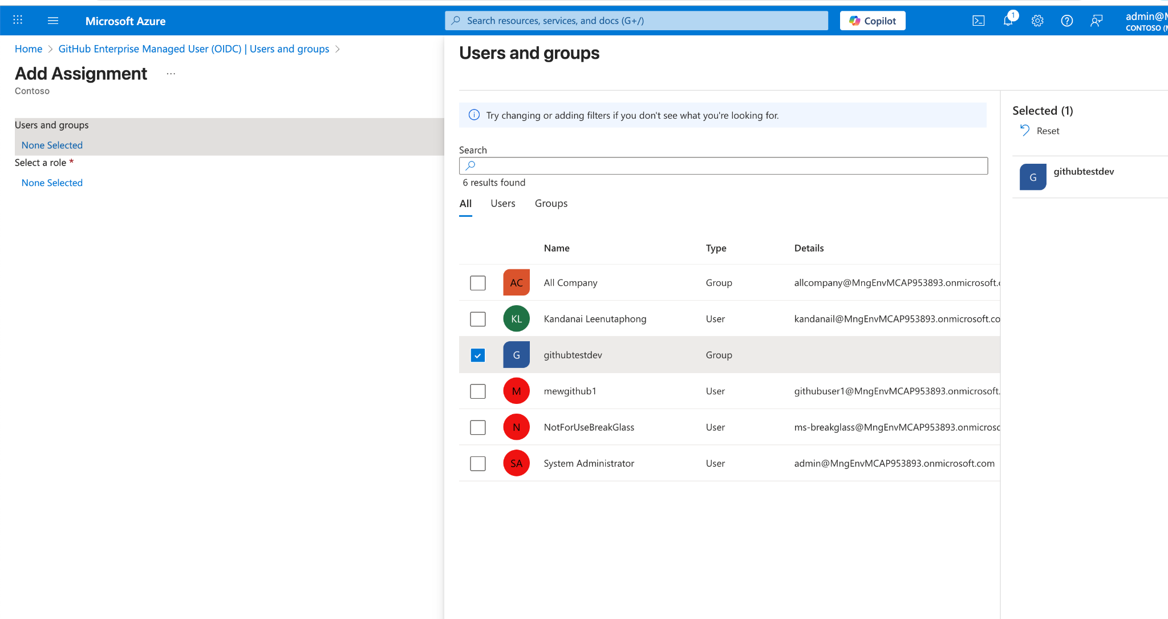

Here I have a group with 4 users, after again waiting 40 minutes, 4 users will be added to the enterprise. I only added one user out of the 4 in the organization. Hence, we can see 3 consumed licenses.

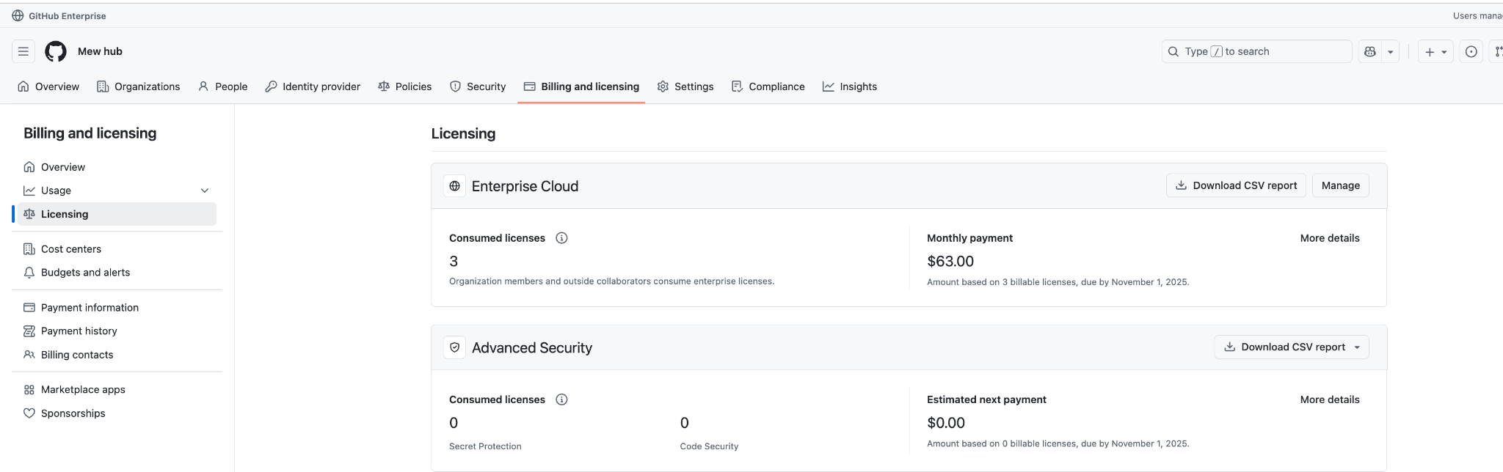

EXTRA Deprovisioning:

You can also remove a member from your microsoft entra id group.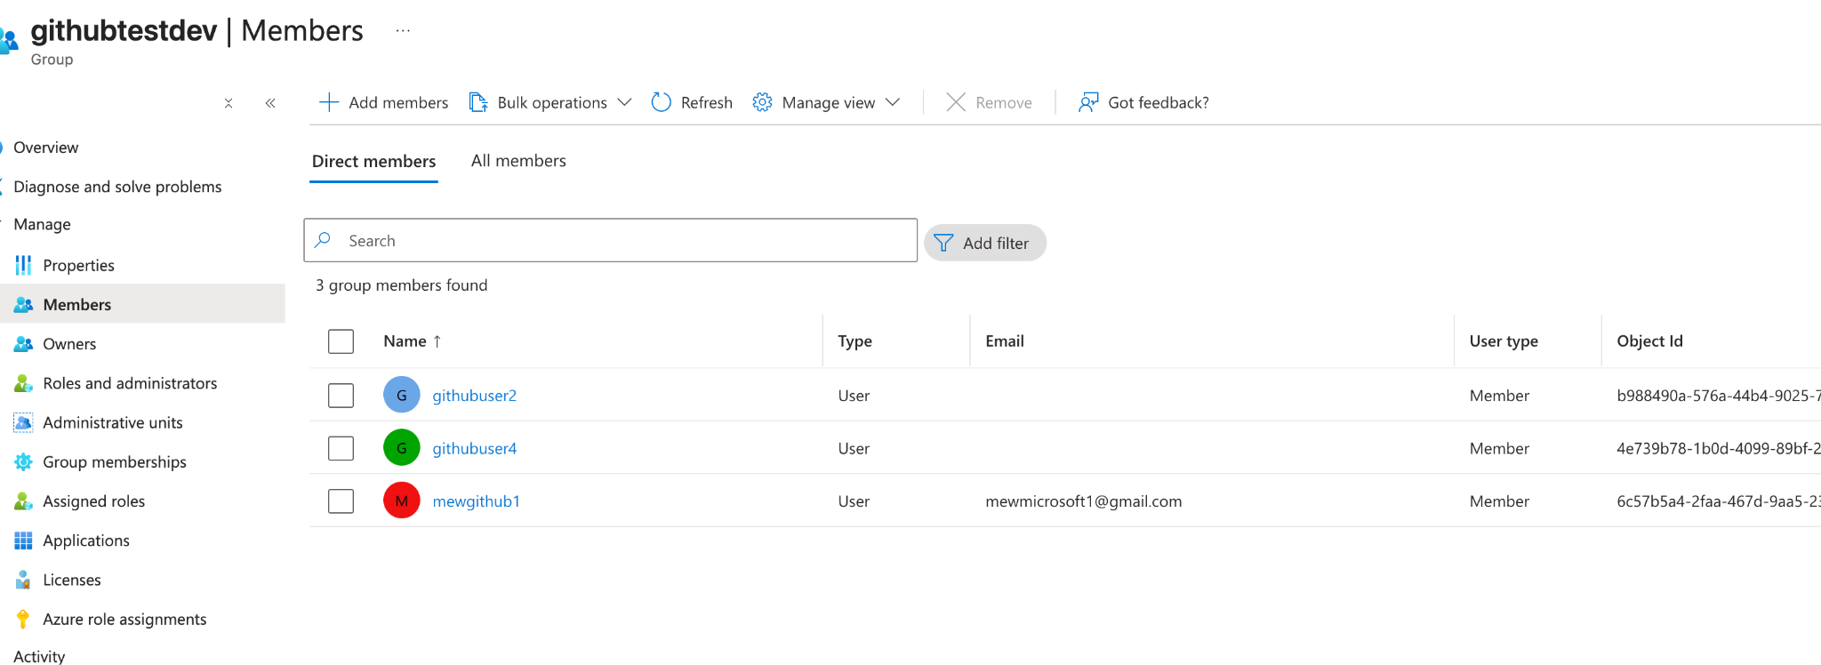

After waiting a while, from

1 group, 4 users

->

1 group, 3 users

We should see.

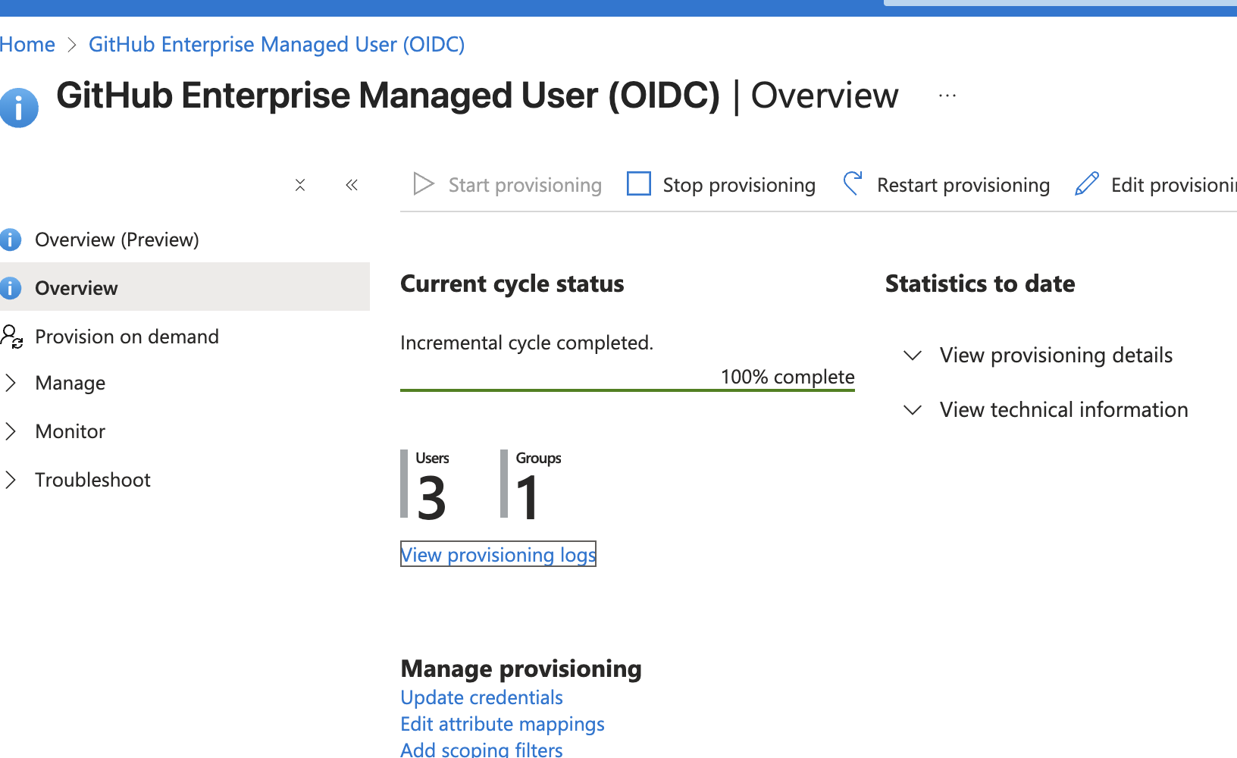

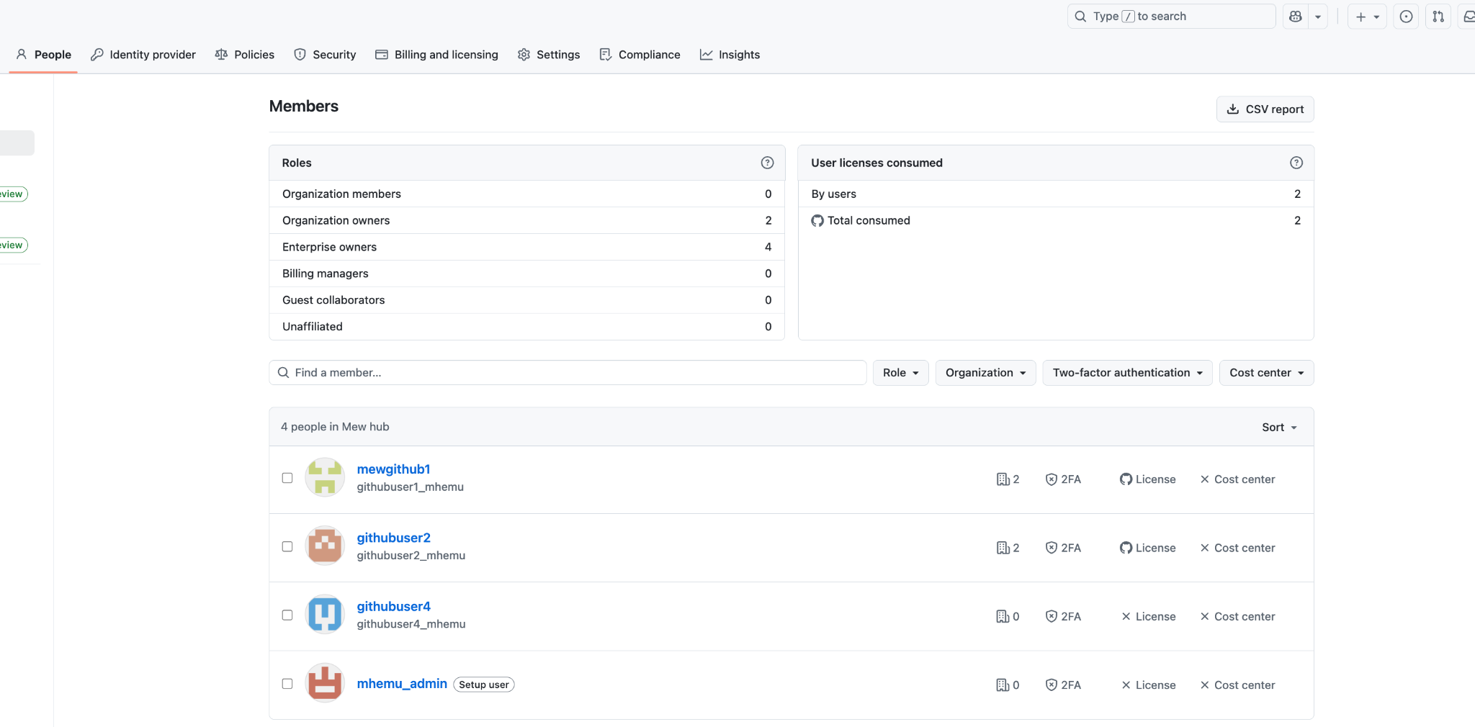

Here you can see the githubuser3 removed.